Office Document Management Device

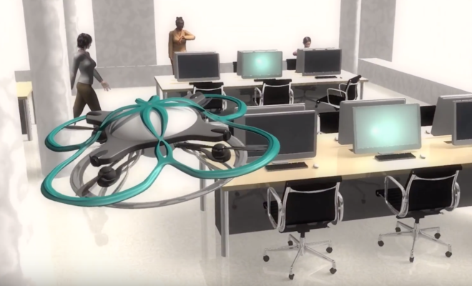

Team members: Chia Wei Tu

Student ID: 300289967

Section: 091

**Table of Contents**

**1.Statement of the problem…………………………………………………Page 3**

**2.Significance of the study…………………………………………….……Page 3**

**3.Project Progress……………………………………………………………. Page 4**

* **Environment Setting……………………………………………………….…Page 4**

**3.1 Implementation**

* **Step 1 Upload Arduino Code to Drone…………………………………….…Page 8**
* **Step 2 Start the Drone………………………………………………….……Page 12**
* **Step 3 Connect to Computer ……………………...……………………...…Page 14**
* **Step 4 Upload Arduino Code to Read Data……….…....…………………Page 15**
* **Step 5 Display on COM4 Monitor………………………….…………….…Page 18**
* **Step 6 Sending Data to Excel………………………….……………………. Page 18**
  1. **Others………………………….……………………………….…….......... Page 19**

**4. Data Analysis……………………….……………………………………. Page.20**

**5. Achievement……………….…………………………………….………. Page.22**

**6. Citation……………………….…………………………………….……...Page.23**

**7. Appendix…………………….…………………………………….……...Page.24**

**1. Statement of the problem**

I work in a big office in Taiwan as a secretary, sometimes feel the document sending back and forth is not that efficiently. It spends lots of time on sending documents and waiting for the financial department’s or accounting department’s confirmation. And the whole **document progress might delay and lost on the track.**

Image we have a paper document manager drone in an office, and it can provide document delivery and also manage the document progress, we could save more time on tracking or deliver this paper work. In today’s technology, indeed there is an office drone which can provide the security camera and record the office working situation. However, if we can add more function on it and even **collect and track the data at the same time,** it might can enhance the office work efficiency.

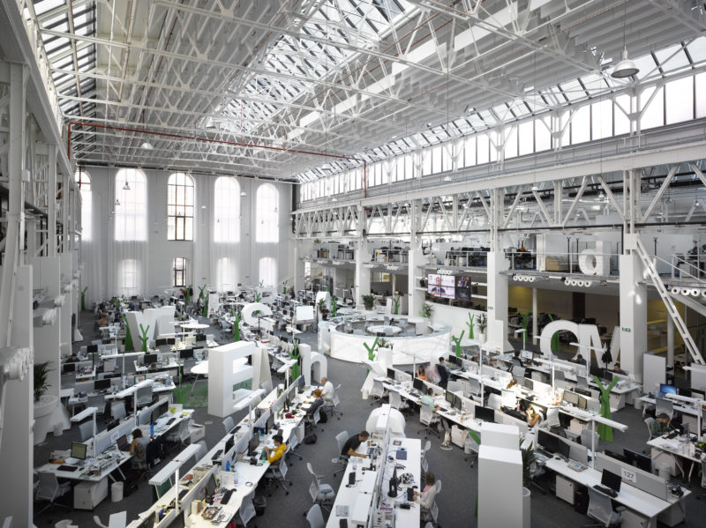

Pic.1-1 Office workplace

**2. Significance of the study**

Because of the advanced technology nowadays, the paper works are getting less and less. The business upgrade to more digital way. However, there are still have some invoices or the sensitive information need to send in a confidential way such like paper document. Moreover, for example, if the senior manager could send their document directly to the destination and avoid through anyone, **it could improve the business information security.** **And we can also collect the office data and record the sending document route which makes the office document progress more clearly and efficiency.**

**Some relevant link and reference:**

<https://www.bbc.com/news/world-asia-42275874>

<https://www.keyman.or.jp/kn/articles/1712/19/news130.html>

**3. Project Progress**

* **Environment Setting**
* Hardware Setting Device- DJI Education Drone (for python and Arduino)

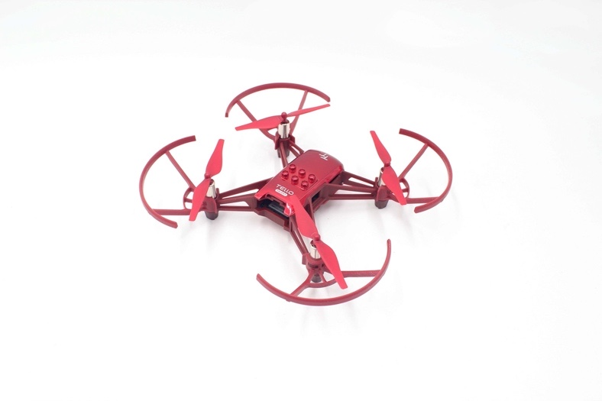

Pic.3-1 RMTT

RoboMaster TT consists of two parts:

* The bottom part is the Tello EDU drone that performs the flying command.
* The top part is the extension module equipped with ESP32 main-controller and 5.8G WIFI module.

Connect the two parts with a micro-USB cable, activate the WIFI module for communication.

* Hardware- Open-source controller

Model: RMTTOC

MCU: ESP32-D2WD, Dual core

ESP8266 uses the open connection of Arduino. It can be connected to the internet to read data by calling the built-in ESP8266 WiFi.h library.

Open source: support SDK, Arduino, MicroPython

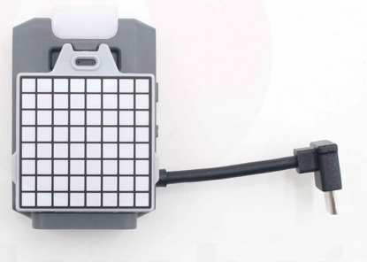

Pic.3-2 open-source controller

* Hardware UML

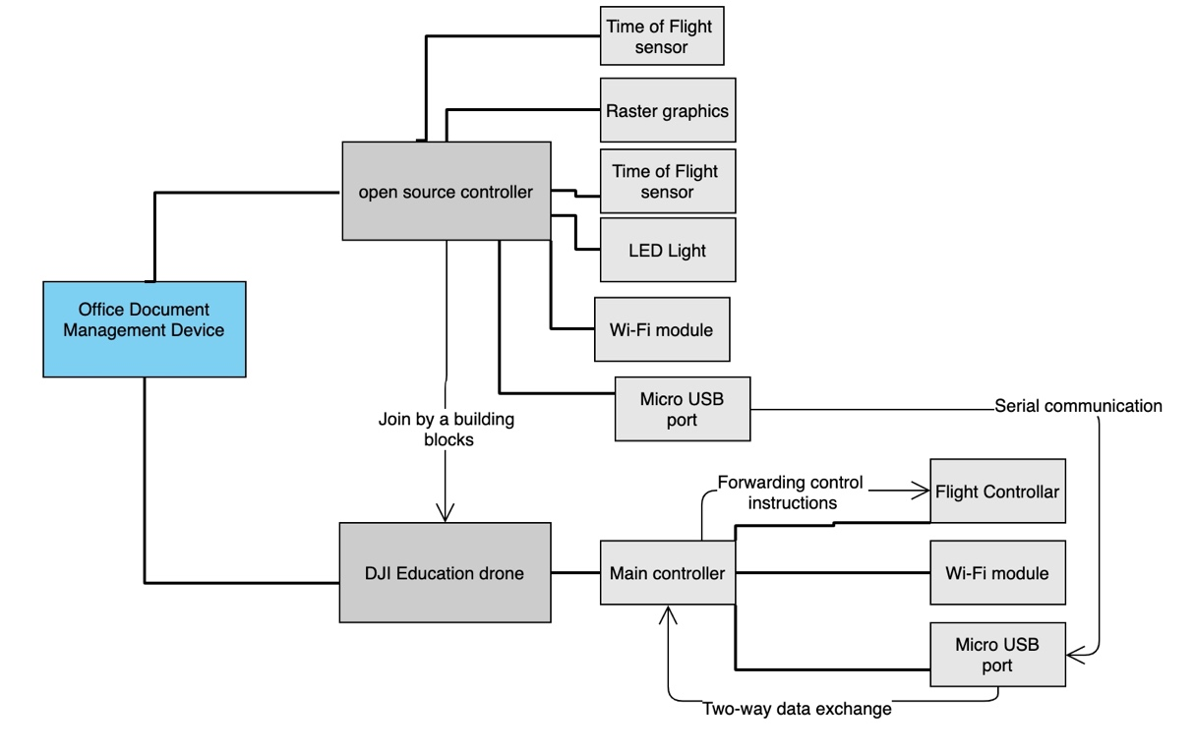

Chart.3-3 Office Document Management Device UML

* Software Design- Arduino IDE

I use this for develop the drone is because it can be matched with sensors or peripheral equipment to achieve the purpose of logical automatic control. It also can connect the computer and through the USB square port cable to provide power and a port for computer programming. Arduino also supports a large number of open source hardware, so I can connect various open source hardware to DJI educational drone to achieve various effects, like AI vision sensor or temperature sensor. And Arduino provide data collection environment which can send the data to any database (Mysql) or excel. For this project, I chose Excel to collect the data from the drone and analyze it.

* Programming UML

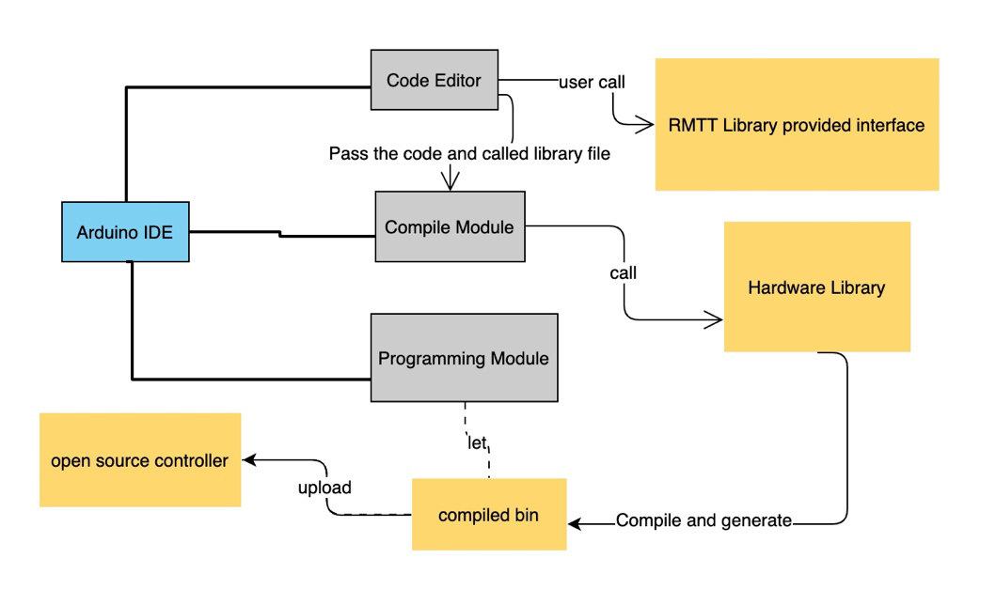

Chart.3-4 Office Document Management Device UML

* Software Design- PLX-DAQ

Parallax Data Acquisition tool (PLX-DAQ) software add-in for Microsoft Excel acquires up to 26 channels of data from any Parallax microcontrollers and drops the numbers into columns as they arrive. PLX-DAQ provides easy spreadsheet analysis of data collected in the field, laboratory analysis of sensors and real-time equipment monitoring.

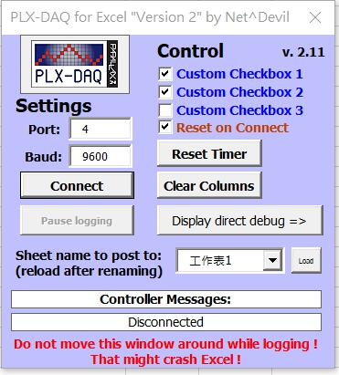

Pic.3-5 PLX-DAQ

**3-1. Implementation** 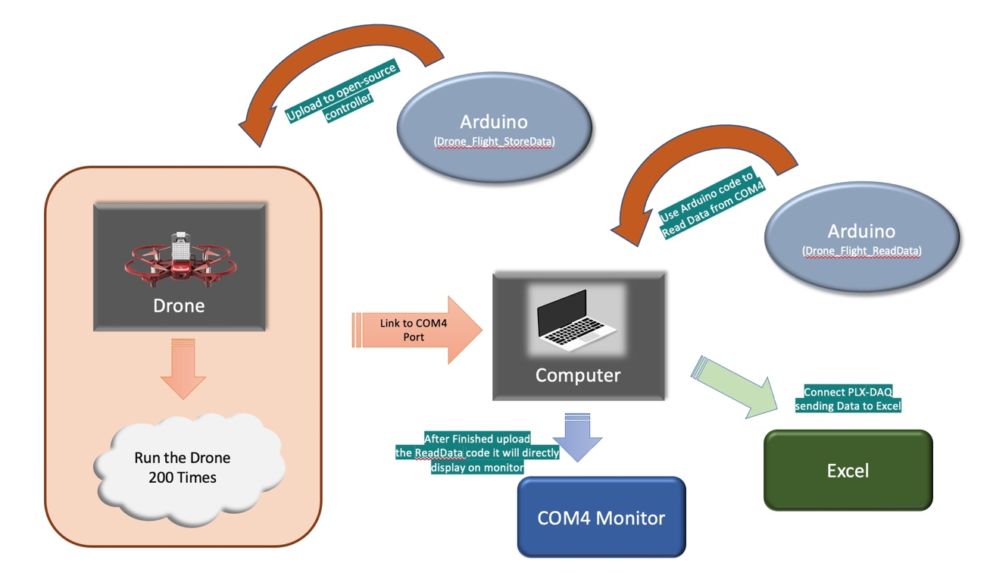

Step 1

Step 2

Step 3

Step 4

Step 5

Step 6

Chart.3-6 Drone implementation UML

**Preface**

There are 6 departments will send their request of documents to director. And if the director accepted their document, it would go to next progress which is financial department.

Financial department will verify their document whether it is works or not and also make sure it is not exceeding the budget. Therefore, the financial department will finalize the decision.

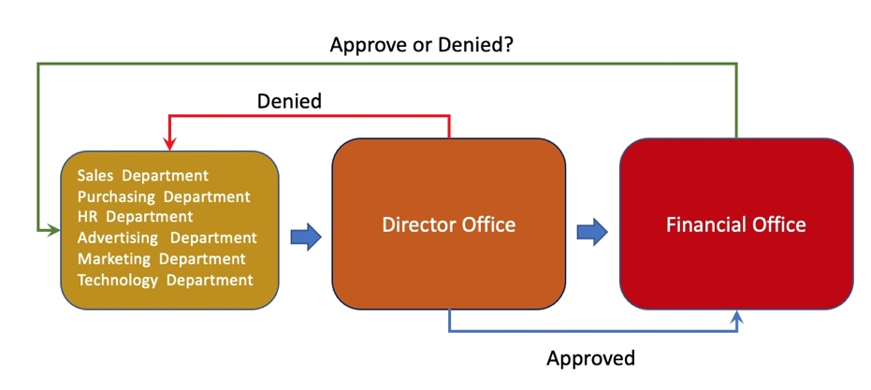

Chart.3-7 Approval progress UML

* **Step 1 Upload Arduino Code to Drone**
* **Drone_Flight_StoreData Program**

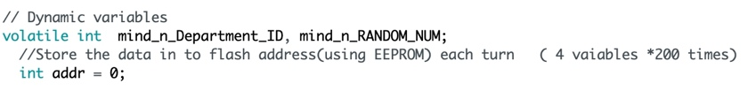

Set the department ID to integer and the random number for generate the decision of approved or denied by director and financial office.

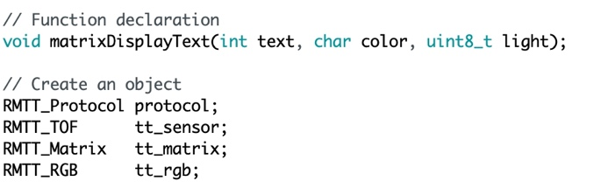

MatixDisplay function is for displaying the dot-matrix LED. It can choose the color (red or blue) and also the brightness.

And the objects protocol is for measuring the location of drone. TOF is for distance sensing module. RGB is for the matrix color.

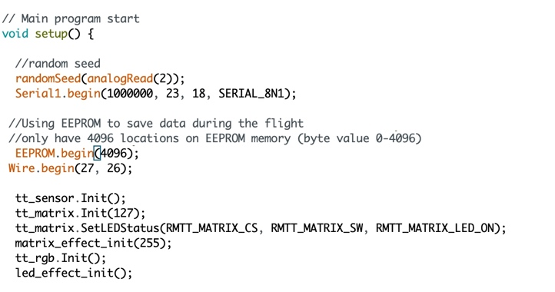

The serial port is set to 1000000 baud on the drone device. (23,18) is the drone original setting serial RX0/TX0.

Set the EEPROM memory to 4096 locations which can be write or read.

Wire.begin()-Initiate the Wire library address.

Initialize the distance sensor and matrix displayer (color, brightness and effect).

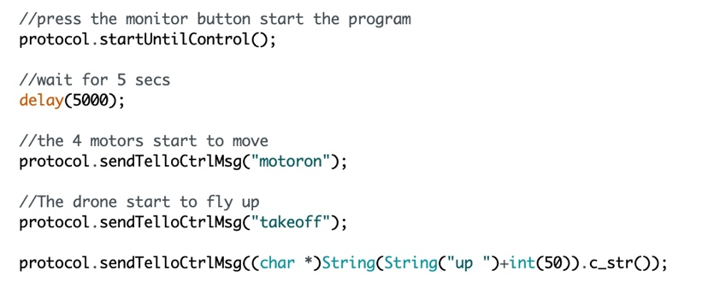

Protocol.startUntilControl(); - after pressing the power button, it will appear the green light.

After the open-source controller showed the green light, if press the open-source controller button, the motor will turn on and start to fly. Then it will fly up to 50 cm height.

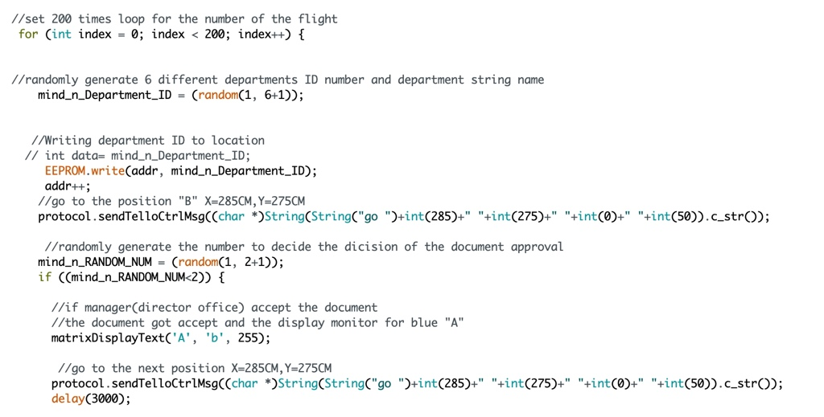

I set 200 times for drone to fly the turns.

It will start to generate the random number for which departments will apply their request of document. And after the department_ID has generated, it will store the value to EEPROM location. (like the chart down below)

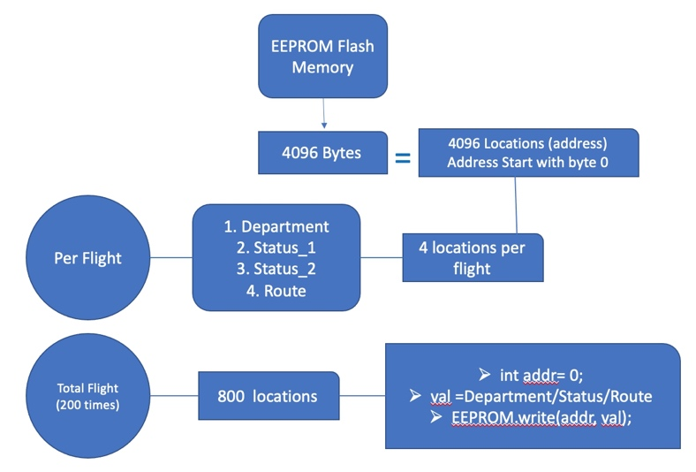

Chart.3-8 EEPROM & Drone UML

After the data was stored, drone will fly to the next position which is the director office waiting for the decision of approval. X : 285 cm and Y axis : 275cm

After the drone move to the second position (director office), it will generate the random number for deciding the approval. If the number is 1, it will display the blue color “A” on the matrix display screen. And then the drone will fly to next position which is financial office.

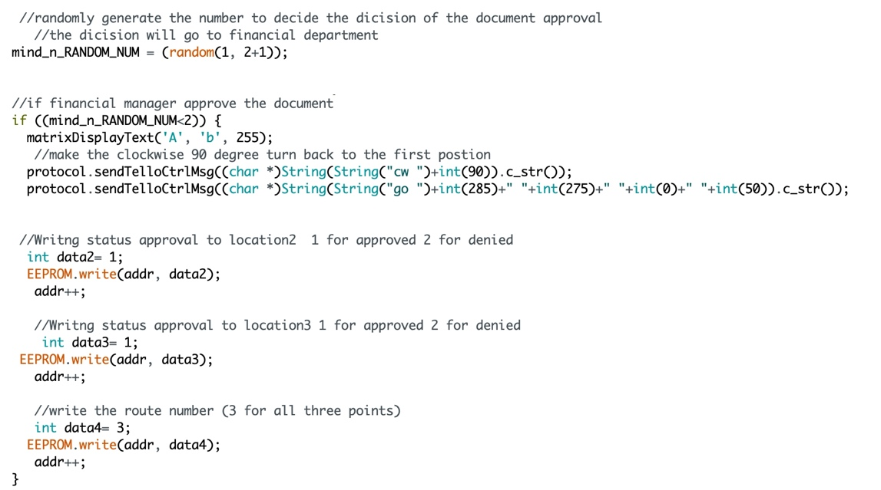

After the drone move to the third position (financial office), it will generate the random number for deciding the approval. If the number is 1, it will display the blue color “A” on the matrix display screen and make the clockwise 90 degree to turn back to the first point (department). And then the drone will fly to next position which is the original department.

After the drone done the turn flight, the data will be stored in EEPROM memory.

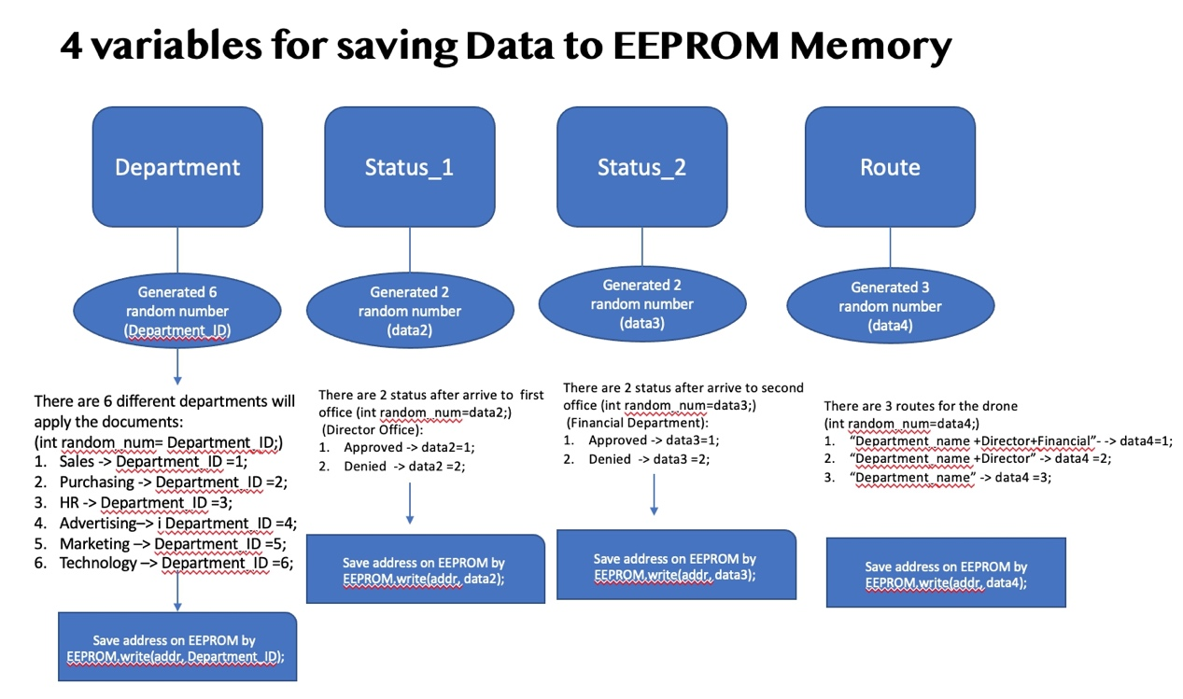

Chart.3-9 Stored data to EEPROM Memory UML

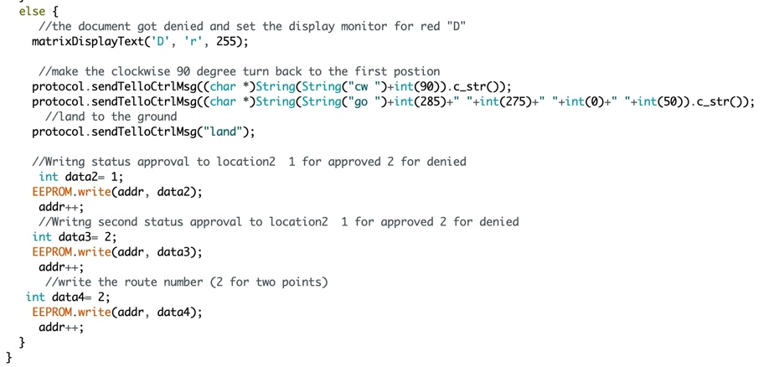

If the second random number created, but it is number 2, the matrix display screen will show red color “D” which means the financial department denied the document and make the clockwise 90 degree to turn back to the first point (department). And then the drone will fly to next position which is the original department.

After the drone done the turn flight, the data will be stored in EEPROM memory.

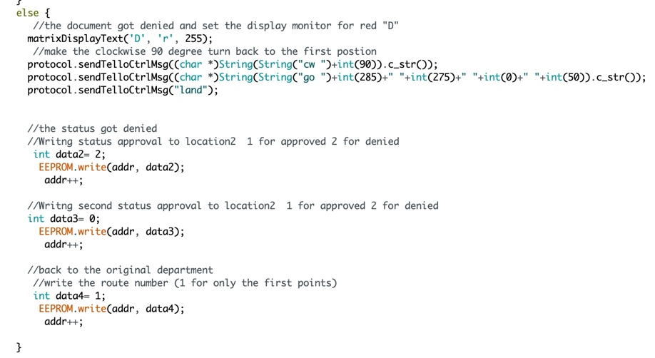

This is the result of first random number created to 2. The matrix screen displays the red “D” which means the document got rejected by director and the drone made the clockwise 90 degree to turn back to the first point (department). After the drone done the turn flight, the data will be stored in EEPROM memory.

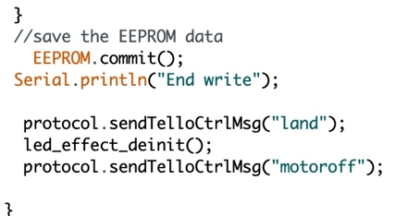

If the 200 times flights completed and the data stored successfully, the serial will get the message. The drone landed down and turned off the motor.

* **Step 2 Start the Drone**

Pressed the power button After the green light showed on the open- resource controller, pressed the button at side of board.

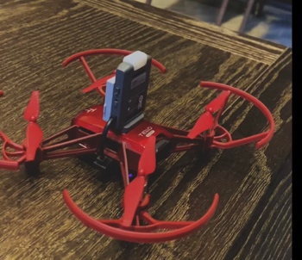 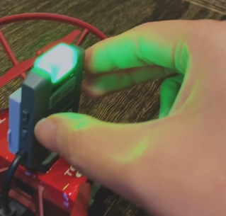

The drone started flying to next position (director office) and waited the decision of approval.

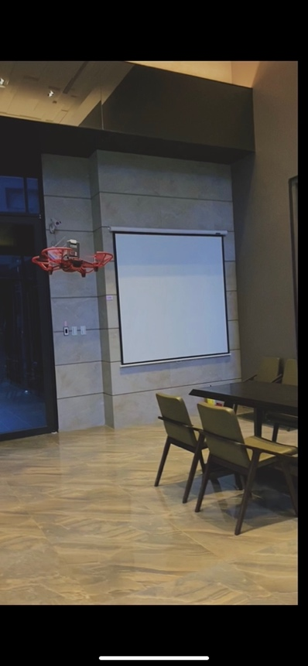  

The random number was 2 which means the director denied the document and it showed the red “D” on the matrix display screen. And the drone turned 90 degree clockwise back to the original point (department). The red “D” displayed the result to the department.

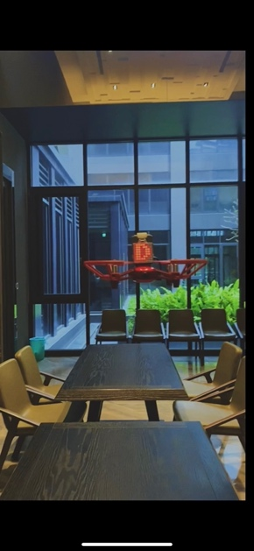 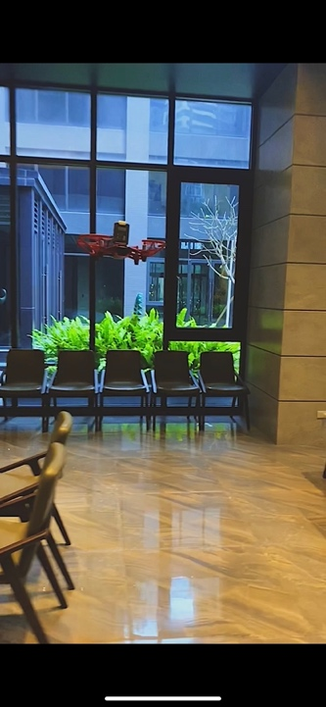 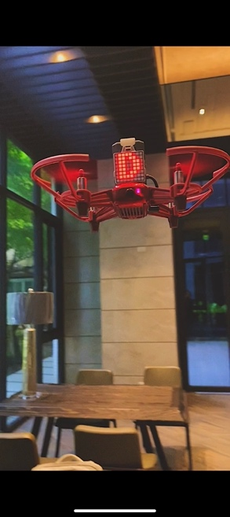

The second possibility was the random number was 1 and it means that the director accepted the document. The drone turned the 90 degrees clockwise to next point. (financial department).

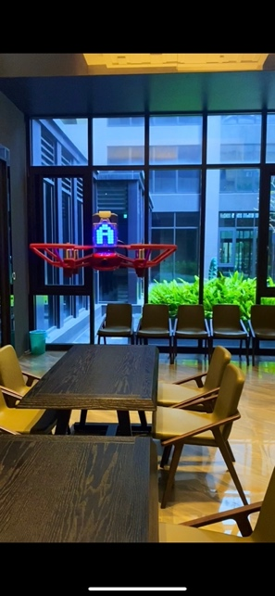 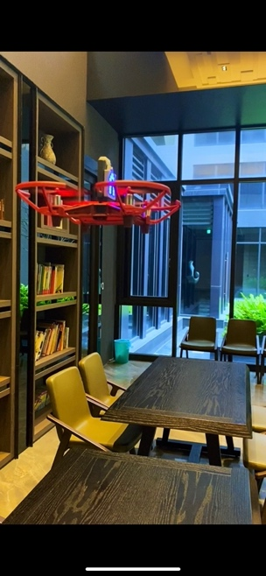 

The drone turned 90 degrees clockwise and displayed the result that got denied by the financial department. Then it came back to the original department and showed the result.

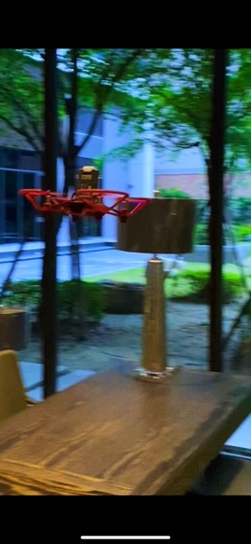 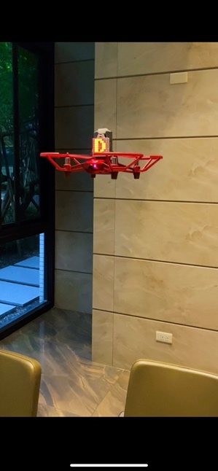 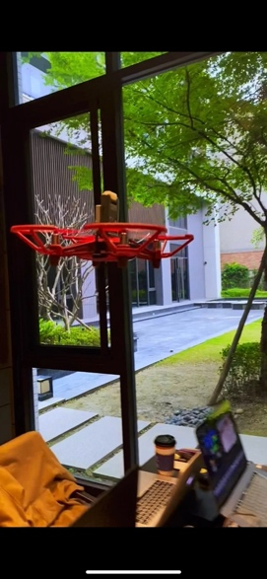 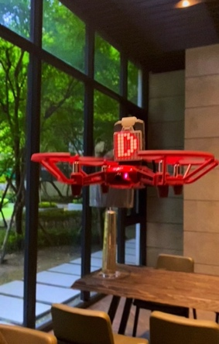

The distance between each point. Set X axis to 285 cm and Y axis to 275 cm.

If the drone moves to next position, it will turn 90 degree clockwise and then move to next spot.

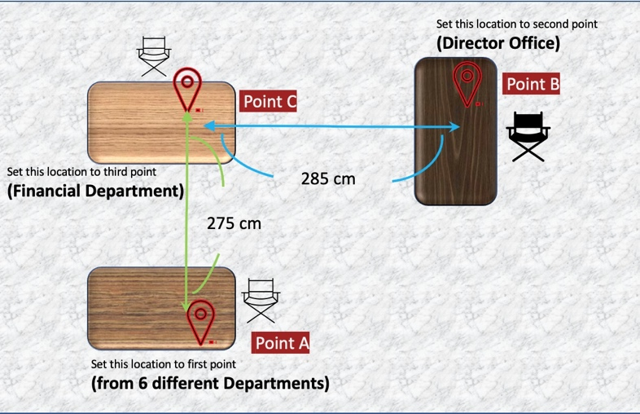

X

y

Chart.3-10 Distance of flight route UML

The route of drone. There are 3 possibilities results of route.

* 1. **Green-> Red** means document got denied by director.
  2. **Green->Blue->RED** means document accepted by director but denied by financial department.
  3. **Green->Blue->Blue** means document both accepted by director and financial department.

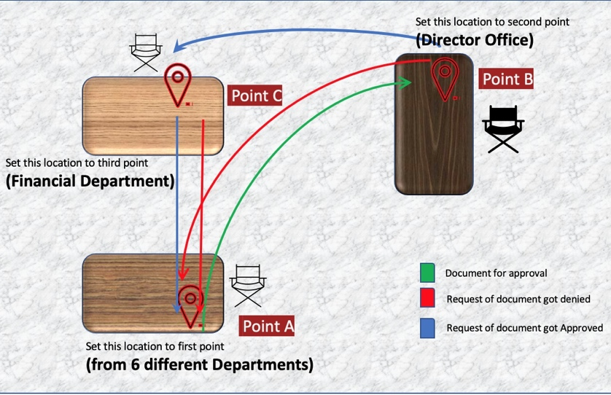

Chart.3-11 Drone Route UML

* **Step 3 Connect to Computer**

After the drone run 200 times, the data will be stored in open-source controller on the drone. I used the Micro USB cable to connect the open-source controller and computer’s COM4 port. The Data was stored in the one-read flash memory called EEPROM on the open-source controller. It has 4096 bytes of EEPROM memory built into the chip. This memory is non-volatile, which means that the data doesn’t get erased when the board have not been reset. So, I also had written an Arduino program (EEprom_clear) to clean the old data before I start the new test on drone.

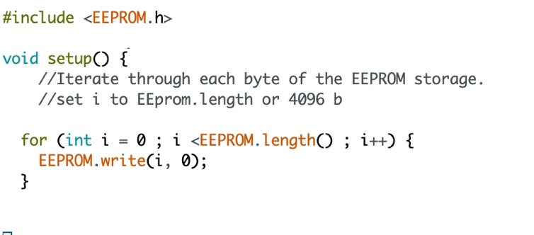

EEprom_clear program sets all of the bytes of the EEPROM to 0. And it depends on the EEPEOM storage like Arduno Duemilanove has 512 bytes EEPROM storage. I use ESP32 board which has 4096 bytes storage in this project.

However, if the data had already stored in open-source controller waiting us to test them, we do not need to clear the memory. Just go to next step uploading the program and read the data.

* **Step 4 Upload Arduino Code to Read Data**

After the drone finish 200 times flights, the data was stored in the EEPROM address (4 variables *200 times). There will be 800 (bytes)address need to be read by Drone_Flight_ReadData Arduino program on the computer through COM4 port.

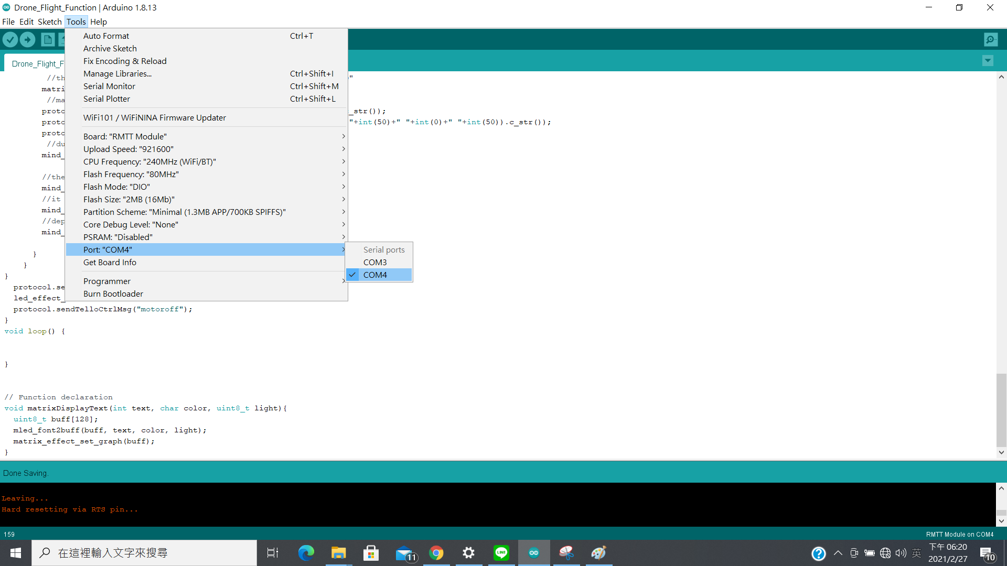

* **Drone_Flight_ReadData Program**

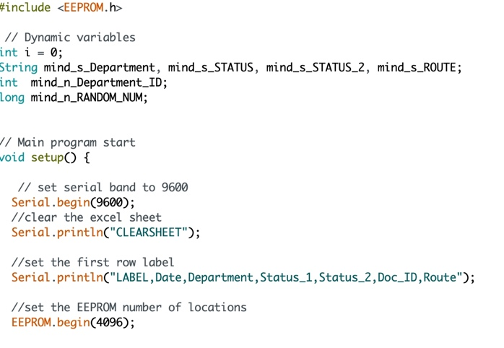

Set the string “department name, status one, status two and route “variables.

And the integer for Department_ID. The data which stored in EEPROM only got the byte data (800 addresses). And the string variables are for datatype of byte transform to string type. Then it can be read to serial port tools.

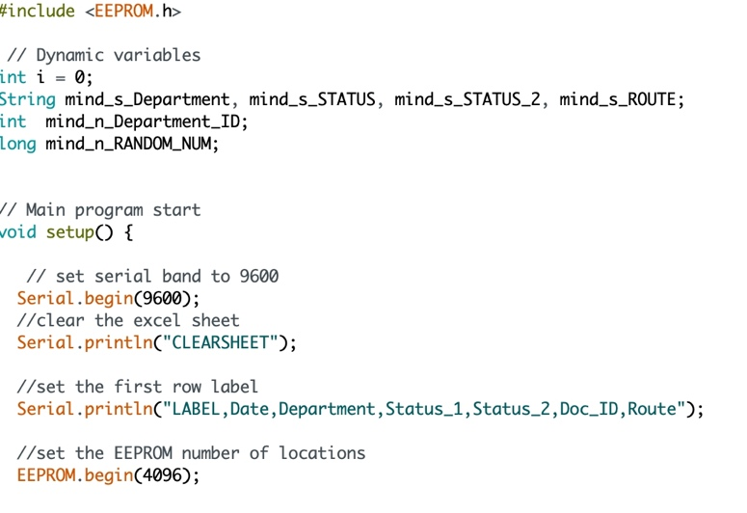

Set the serial port baud to 9600 and then clear the old data from excel.

(“CLEARSHEET”) is the function in PLX-DAQ to clear the sheet. After PLX-DAQ connect to the Drone_Flight_ReadData Program, it will clean the old data automatically. Then it will print the label in first row.

EEPROM.begin(4096) is the volume of data what we want to let EEPROM write or read. I set the maximum of volume to read my data. (4096 bytes)

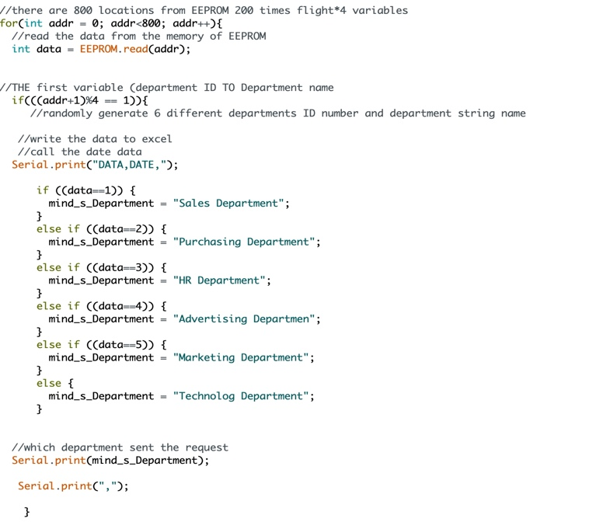

The drone had run 200 times during the whole program (Drone_Flight_StoreData).

It stored 4 variables in each flight. So, there will be 800 bytes data to be read.

Use EEPROM.read(addr) to read the data in each address from the EEPROM flash memory.

The first variable is department_ID which generated by randomly. There will be 1~6 numbers represent each department.

(addr+1)%==1 means the number of address is the remains of 1. (EEPROM address start from 0)

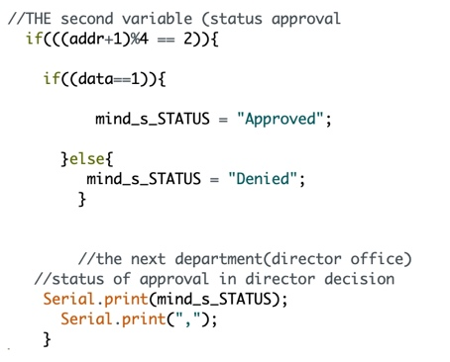

The second variable is the status of director approval. There are 2 status for approved or denied. (addr+1)%==2 means the number of address is the remains of 2 .

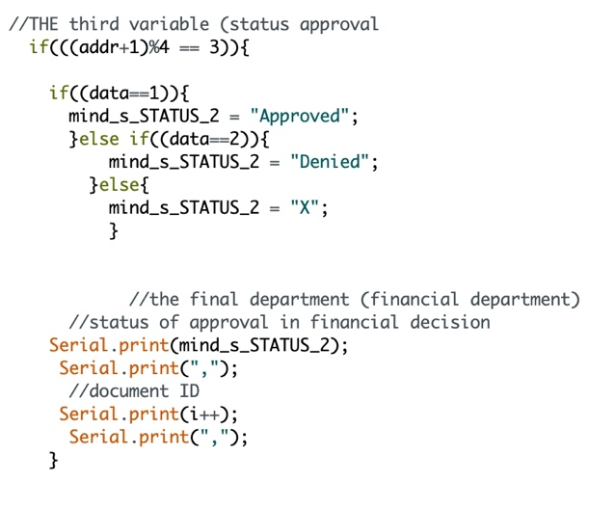

The third variable is the status of financial department approval. Financial department will be the last department to verify the document whether is approve or not. There also have 2 status for approved or denied. (addr+1)%==3 means the number of address is the remains of 3 which is the third variable in per flight.

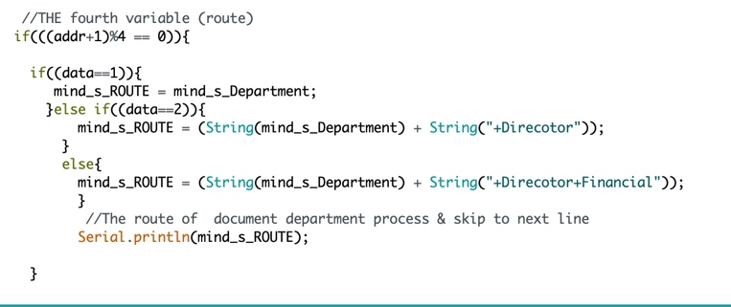

The fourth variable represent the route. The route only records the approved document departments. If the data is 1, it will go through the whole route which means it will from the department which request the document to director office and the last location-financial office. This means the director and the financial office both approved the document. If the data is 2, it will from department to director office and the financial office. However, the document was rejected by the financial office. If the data is 3, it will only from department to director office. However, the document will be rejected by the director and back to the original department.

* **Step 5 Display on COM4 Monitor**

After the Drone_Flight_ReadData uploaded to the open-source controller, the data will be showed on the COM4 monitor. If the data display the pattern like this: “DATA”, “DATE”, “Department”, “Status_1”, “Status 2”, “Document ID”, “Route of Office Point”, it means the data have been successfully read by Arduino.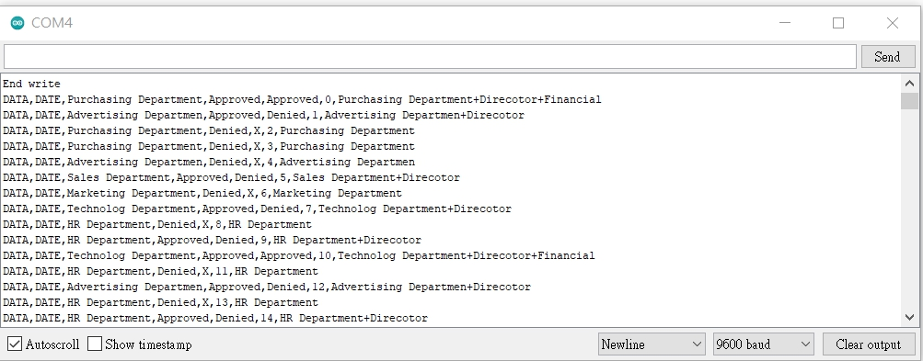

* **Step 6 Sending Data to Excel**

Before sending the data to excel, COM4 port should be closed first. Otherwise, the serial port cannot be connected by other serial port tools. I used Parallax Data Acquisition tool (PLX-DAQ) to retrieve the data from serial port. Modify the port of the PLX_DAQ window to COM4, and then press connect button to receive the data.

**-The data will generate randomly by rows**

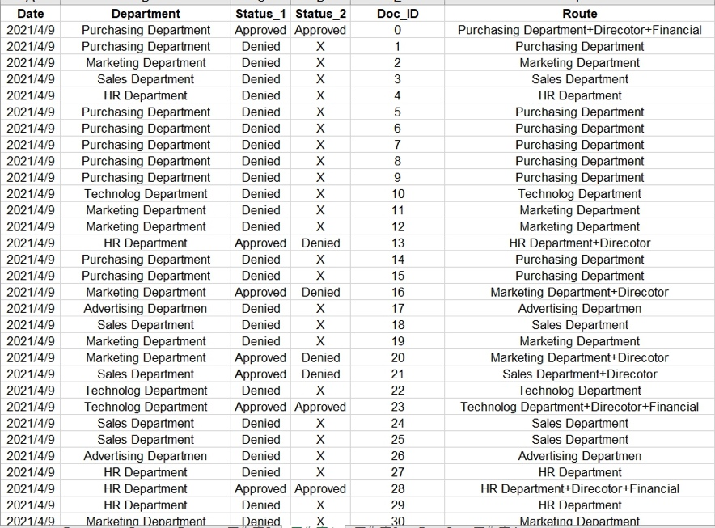

The data will be recorded as “Date”, “Department”, “Status_1”, “Status_2”,” DOC_ID” and “Route”. For these data, I can get data which from a randomly decision and analysis which department spend most of the time for the document approval or the volume of the documents in each department. However, now I only can observe from the test data. If I can apply this in real world, take the office for example, it might increase the efficiency of the work and reduce the paper loads. Moreover, I can analysis every departments documents process which make the office administration more clearly and smoothly.

**3.2 Others**

I had written other Arduino program (Flight_store) which is for only upload the program to open-source controller through the computer (do not have to test on drone). Before running this program, it should clear the old data through EEprom_clear program. And then upload Flight_store program to open-source controller. After stored the data in EEPROM memory, it can be read by Drone_Flight_ReadData program. Flight_store program is basically similar to Drone_Flight_StoreData but subtract the drone flight function. Because sometimes the drone cannot be flighting all the 200 times and the data were also not stored well, I just delete some flight function make sure the data can be stored in EEPROM perfectly and also is simpler to compile on the computer.

* 1. **Data Analysis**

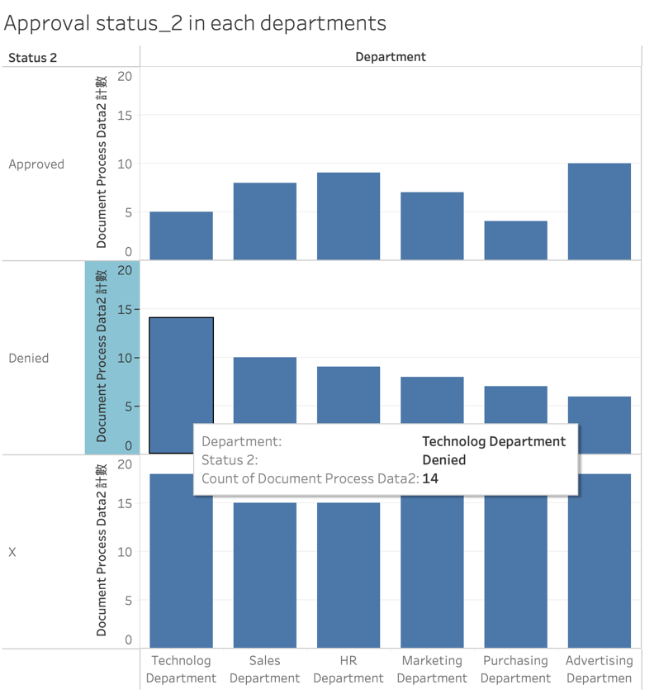

Chart.4-1 Approval status_2 in department

The chart above shows that the technology department got the most denied document during the status 2 which is from financial department.

In real world, we might think that maybe is because most of tech-equipment are really expensive and the company already have the replacement plan to cut down the budget.

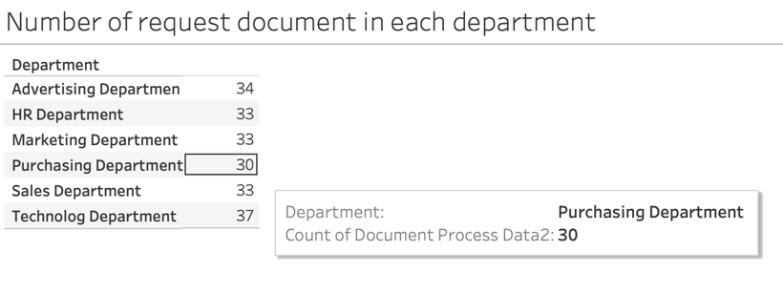

Chart.4-2 Number of request document in department

The chart shows that the purchasing department got fewer requests of document.

This might because of the purchasing department will consider the cost, volume of product, time during their daily work. So, they might not send the request more than other departments.

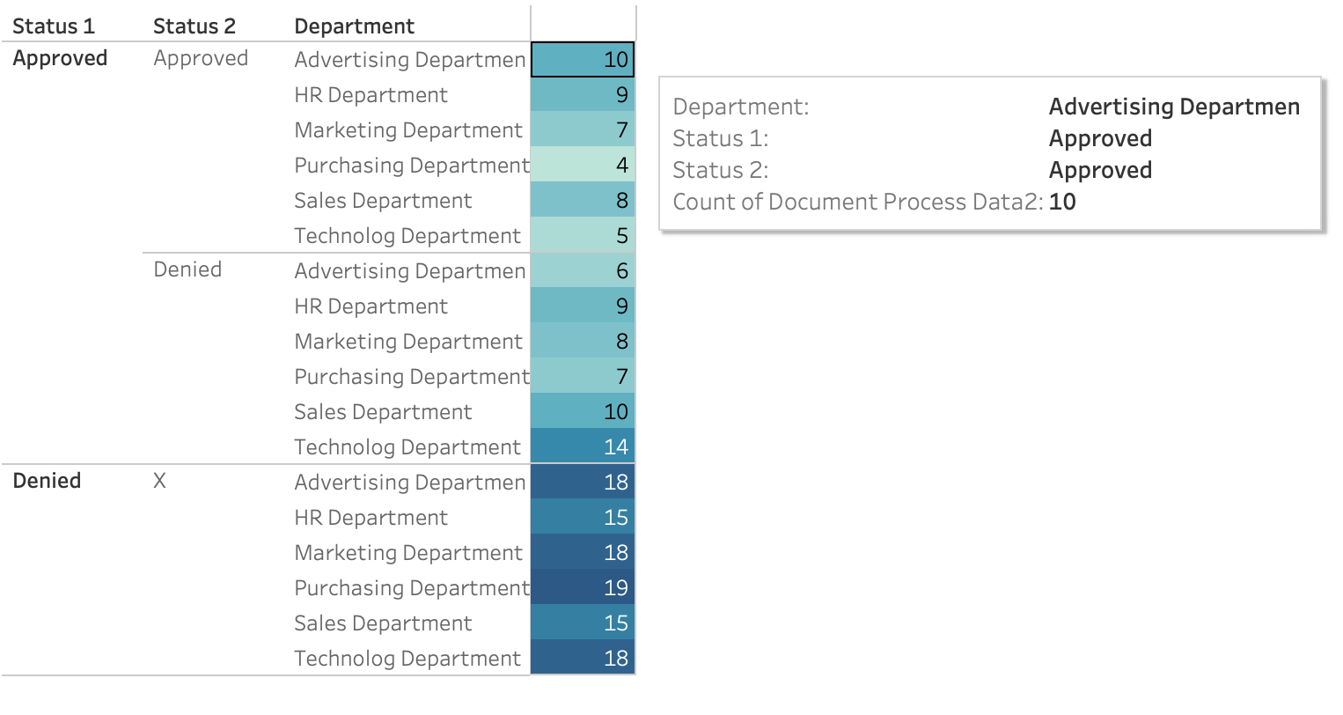

Chart.4-3 Approval status in department

The chart displays the status and numbers in director office and financial office in each department. We can see that advertising department got most approval from both director and financial department. It means they have most possibility to pass the projects and plans. It may consider the reason that the brand of company is really important. Investing more in advertising will increase their popularity and profits.

**5.Achievement**

After finished this project, I had experienced the whole process of drone implementation including software and hardware. I think the difficult part is how we really accept this using in an indoor space. Drone has so many problems such like the battery, the safety and the noise of drone. I must say this will be a big project if people would like to use in real life. Moreover, I think the software part needs to put more efforts to it. Indeed, the data can be written and read through the drone. But the data I used was just a simple one and only recorded the status and bytes. If there are more information and data need to be stored and send such like some description, it might need a bigger memory storage. However, I think it still really good to try and have high possibility to make this dream come true. The drone is become a common tool now. It provides convenient, lower cost environment and saving lots of time to us. The hardware is not a big problem because the Arduino is a great environment to develop suitable board which can use in drone in the future.

During the laborious country, quantity tends to drown out any other requirements. With the heavy workload and some of the large-scale company, efficiency influence a lot on office work progress. Office drone probably is a great idea to sending the files and documents making the office document progress more efficiently and smoothly.

The other achievement is, in Japan, quality clearly does matter, they already created the drone that can use in office. However, Japan’s office drone is about the camera monitor the employee’s situation. Japanese office security company Tasei try to monitor some over desks with employees working late and use drone to make them go home. Due to this invention, not only will it optimise work and make its quality more important than its duration, but it may just make the end of every working day a TGIF to boot.

**6.Citations**

**Pic.1-1 office workplace -** [**https://officesnapshots.com/2013/12/09/9-inspirational-open-office-workspaces/**](https://officesnapshots.com/2013/12/09/9-inspirational-open-office-workspaces/)

**Pic 2-1 RMTT-**

[**https://www.kodorobot.com/product/dji-robomaster-tt-%E6%95%99%E8%82%B2%E7%84%A1%E4%BA%BA%E6%A9%9F/**](https://www.kodorobot.com/product/dji-robomaster-tt-%E6%95%99%E8%82%B2%E7%84%A1%E4%BA%BA%E6%A9%9F/)

**Pic 2-2 Open-source controller-**

[**https://www.kodorobot.com/product/dji-robomaster-tt-%E6%95%99%E8%82%B2%E7%84%A1%E4%BA%BA%E6%A9%9F/**](https://www.kodorobot.com/product/dji-robomaster-tt-%E6%95%99%E8%82%B2%E7%84%A1%E4%BA%BA%E6%A9%9F/)

**Pic 2-2 PLX-DAQ(After downloaded and screen shot from it)-**

[**https://plx-daq.software.informer.com/**](https://plx-daq.software.informer.com/)

**Website:**

1. **Arduino download and codes**

[**https://www.arduino.cc/en/software**](https://www.arduino.cc/en/software)

1. **RoboMaster_TT_Tello_Talent_Quick_Start_Guide.pdf**

[**https://dl.djicdn.com/downloads/RoboMaster%20TT/RoboMaster_TT_Tello_Talent_Quick_Start_Guide.pdf**](https://dl.djicdn.com/downloads/RoboMaster%20TT/RoboMaster_TT_Tello_Talent_Quick_Start_Guide.pdf)

1. **EEPROM Store DATA function**

[**https://www.norwegiancreations.com/2017/02/using-eeprom-to-store-data-on-the-arduino/**](https://www.norwegiancreations.com/2017/02/using-eeprom-to-store-data-on-the-arduino/)

1. **Drone Articles BBC News about Office Drone**

[**https://www.bbc.com/news/world-asia-42275874**](https://www.bbc.com/news/world-asia-42275874)

1. **Drone Articles 2- Japanese Drone**

**<https://www.keyman.or.jp/kn/articles/1712/19/news130.html>**

**7.Appendix**

**Monitoring and Evaluation**

Indicators: **Process indicators**

**No of the office have implement the document drone yet.**

1. ***Reliable:*** It can have the same result in repeated trail (the document drone input the status in to drone system means the mission is done every time)
2. ***Valid:*** Document drone intend track the document status.
3. ***Measurable:*** It can collect the checking status data and compute the percent of the document progress.
4. ***Practicable:*** I have drone parts (have not combinate it yet)

Propellers, motors, battery, screws, PAW remote controller PCB assembly micro module, Barings and others. And I can implement the document drone in my workplace(office).

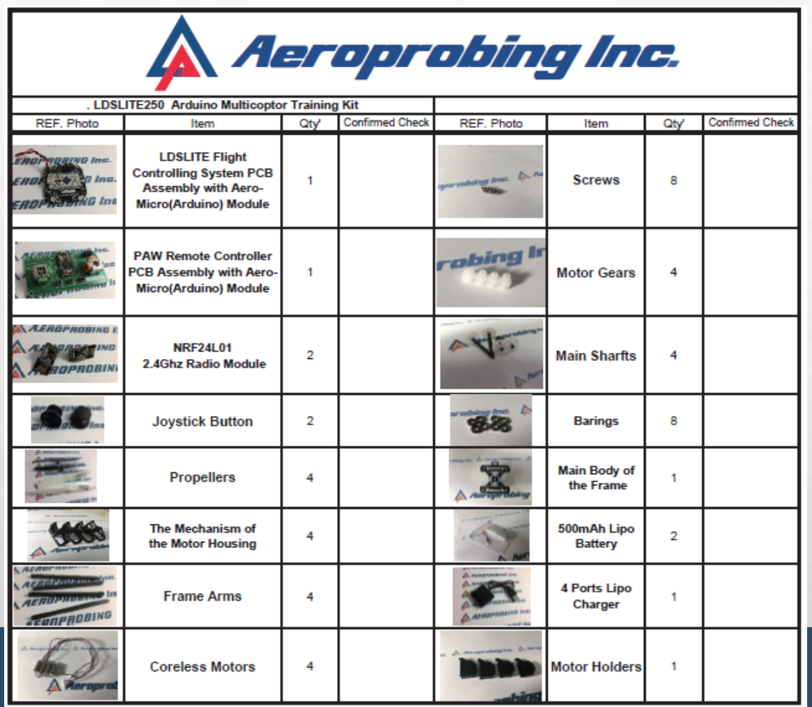

**Project Implementation**

**Report 1 Outline**

I have finished the progress of the report 1(Arduino controller program). However, the hardware which I build up myself is not that suitable for more than 5 mins flight, the controller is not that stable yet as well. So, I have changed the device which is the education drone for written the code in Arduino. I have done the draft code of the position and decision of the manager (accepted the document or not). For the midterm, I will update more specific code and add the data function in each turn flight as well. And for the report 2, I will focus on the data collection. If I am on the good track at that time, I would use the gesture sensor in deciding the document pass or not.

-Drone hardware setting

The PAW remote controller (green one) and the LDSLITE flight controlling system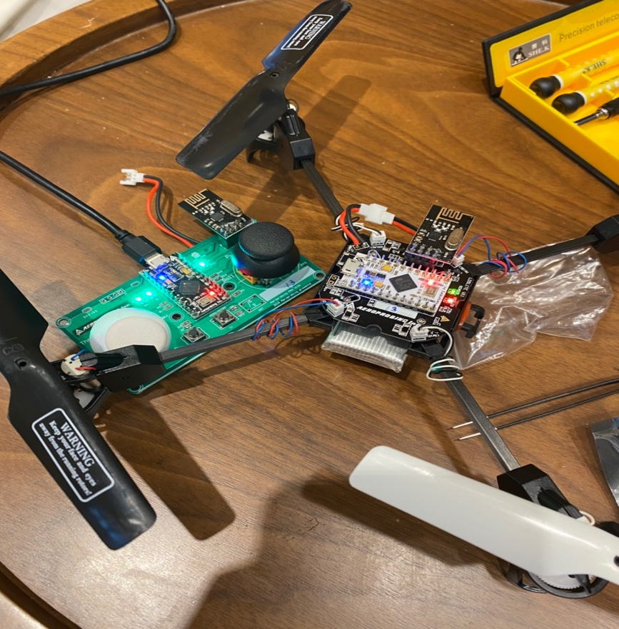

Remote Controller Arduino Code

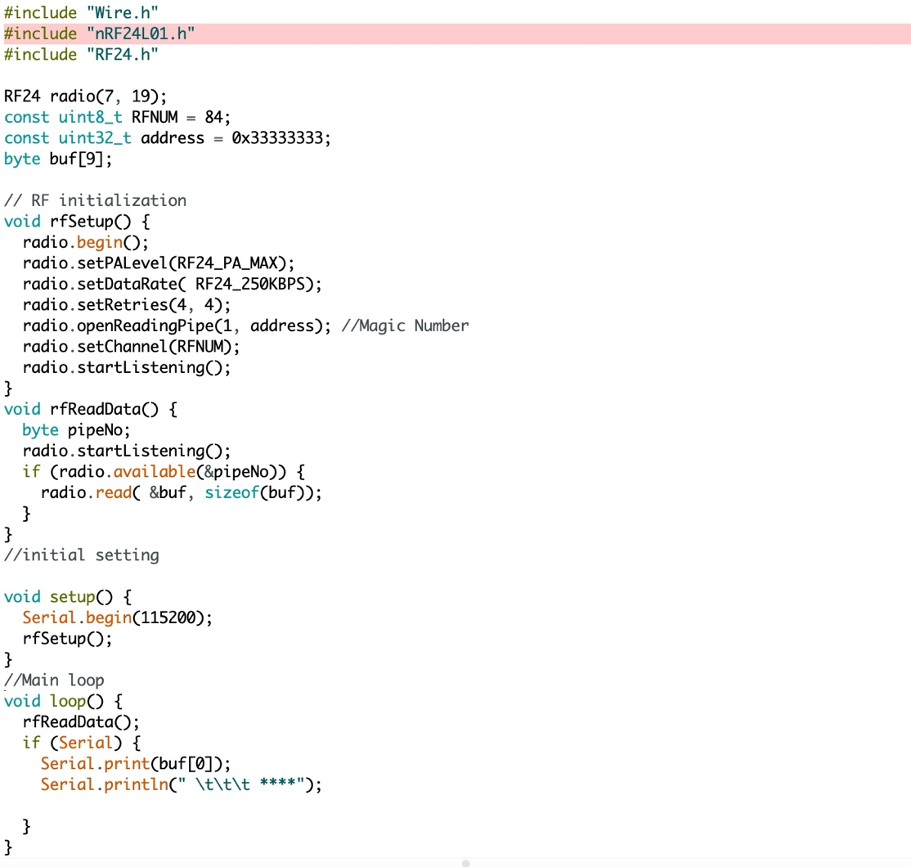

LDSLITE flight controlling system Arduino code (not finish yet)

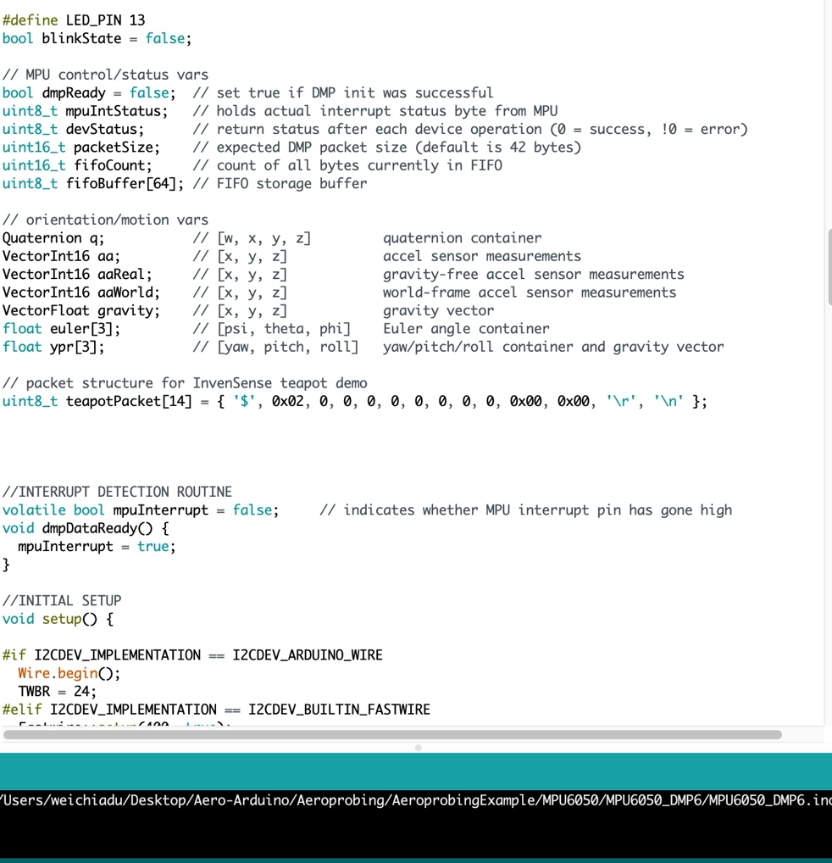

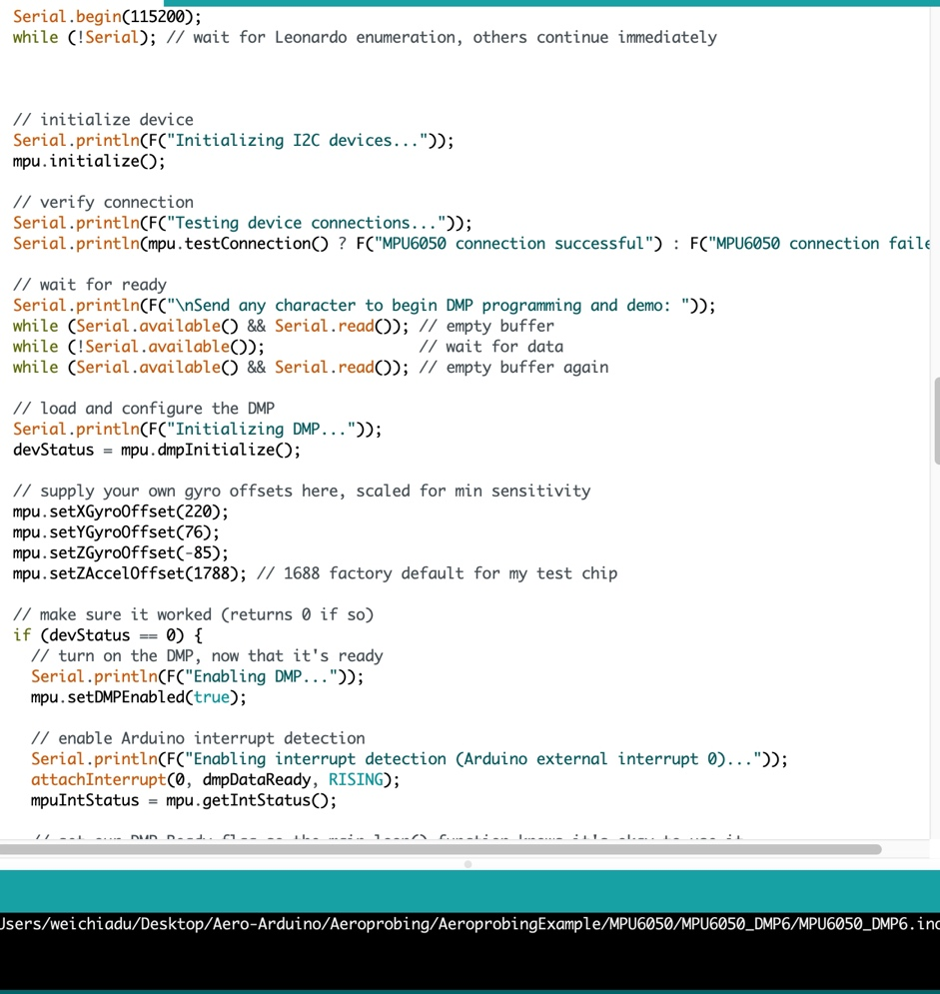

Finished date: 1/25-1/29

**-Plan B for implementation**

**Writing the Arduino code into another Drone device**

Waiting the green light and press the button on the side of open-source controller

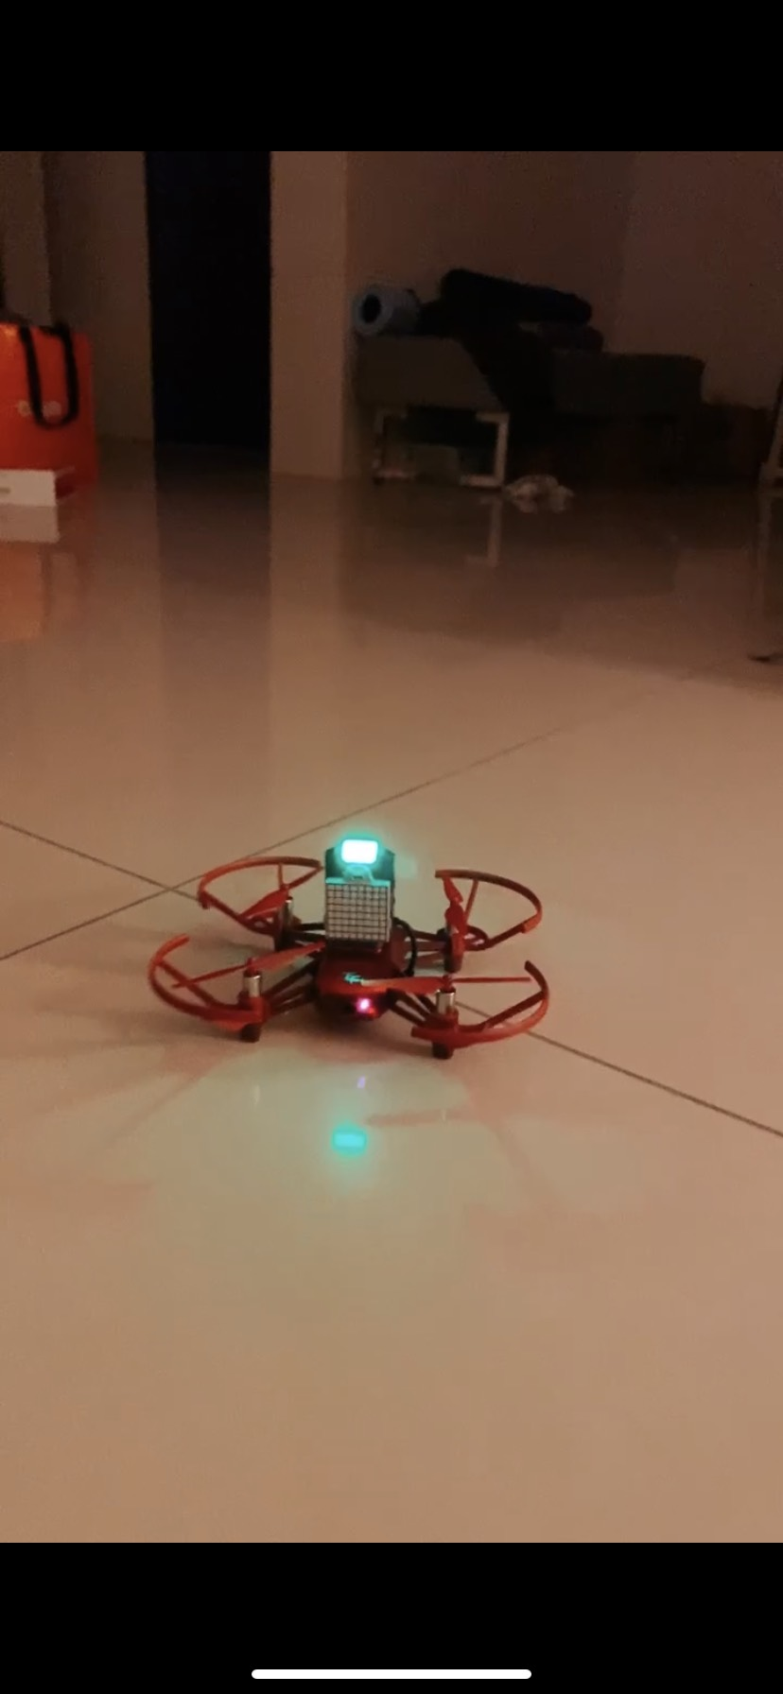

The drone flies up when it starts.

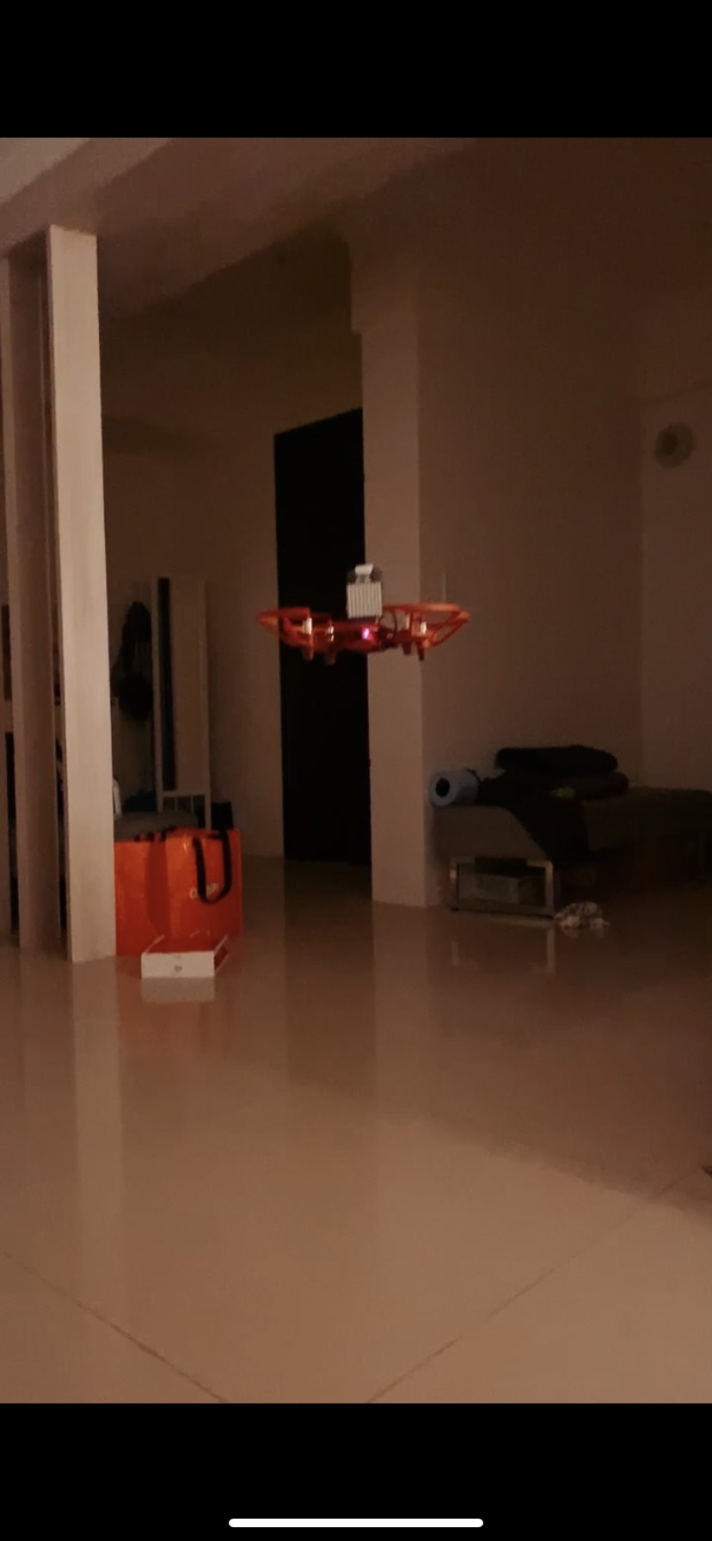

For this phase, I use the random number function to decide the decision.

The random number (1 to 2) function decides the “A” or “D” and the future position.

The letter shows on the Dot Matrix Display.

Accepted and Denied the document.

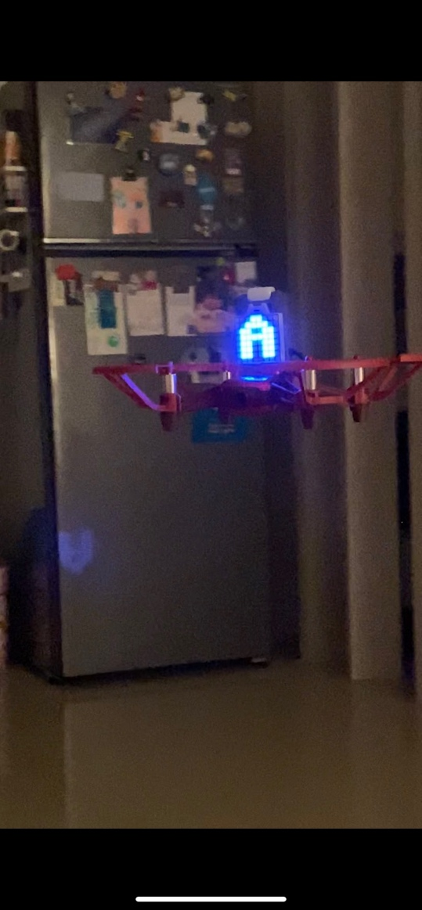 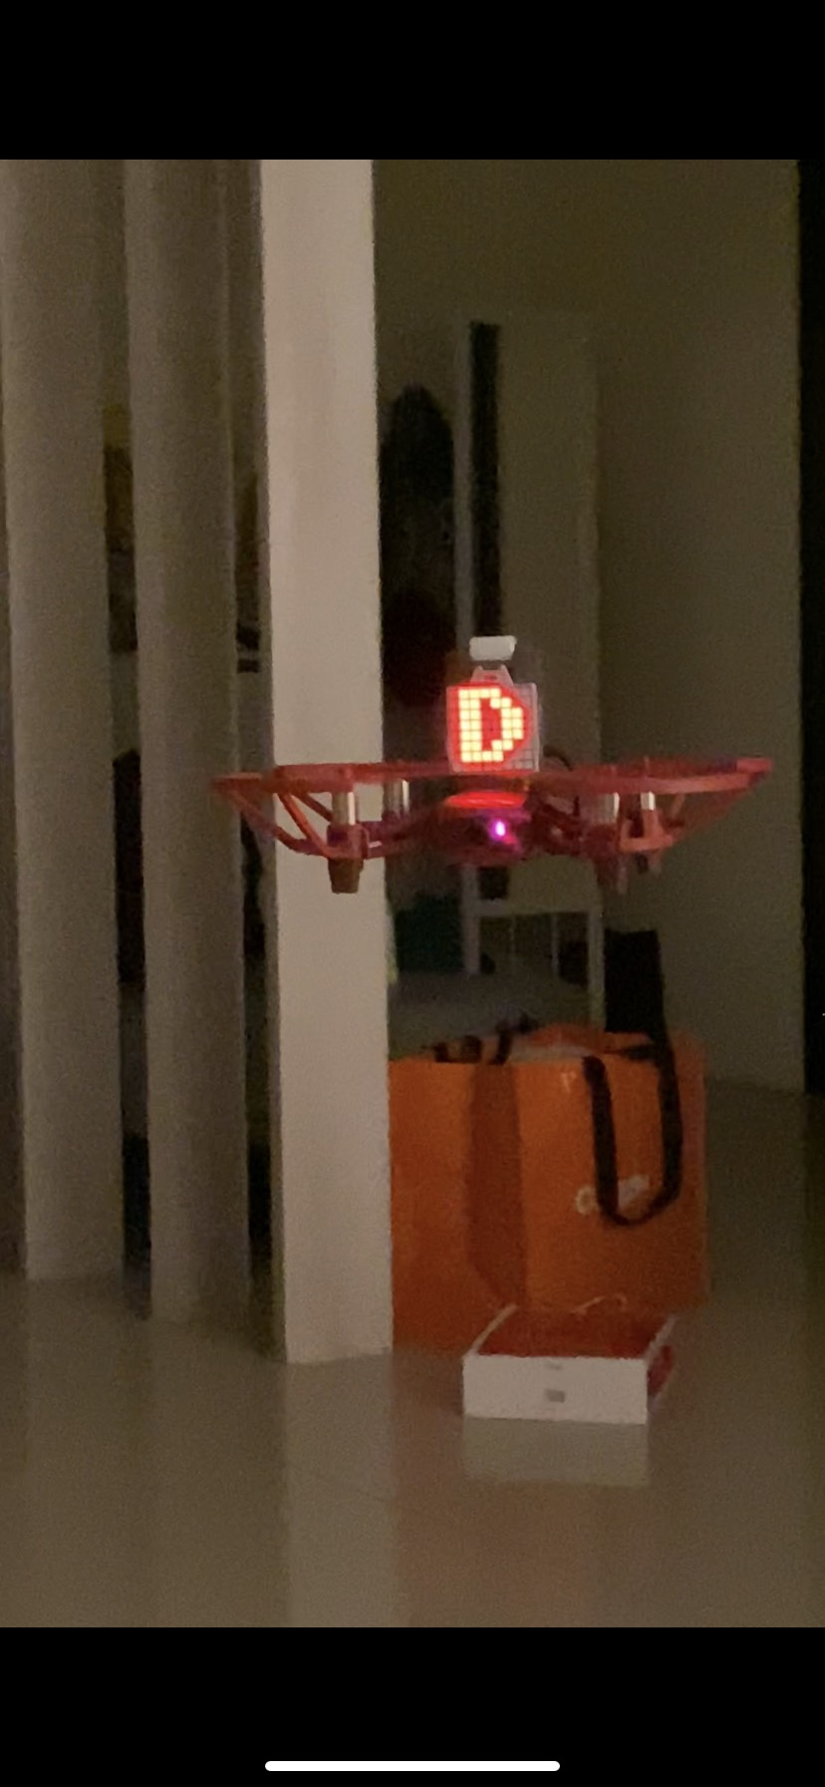

And it will fly to next position or back to the original one.

**Arduino code for the drone position changing from A to B**

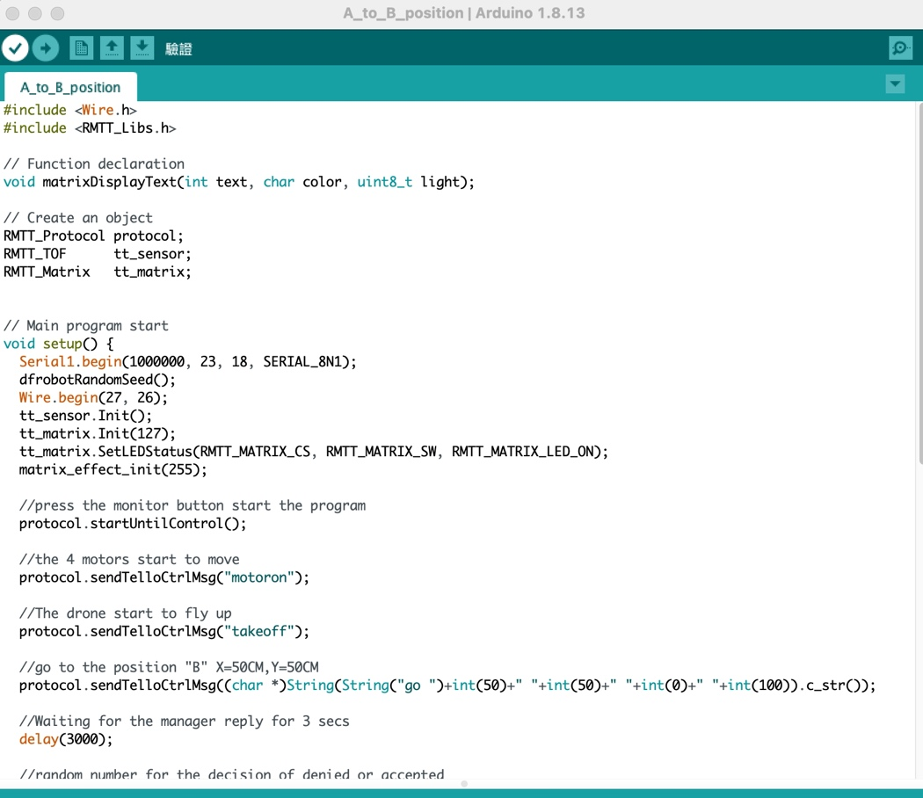

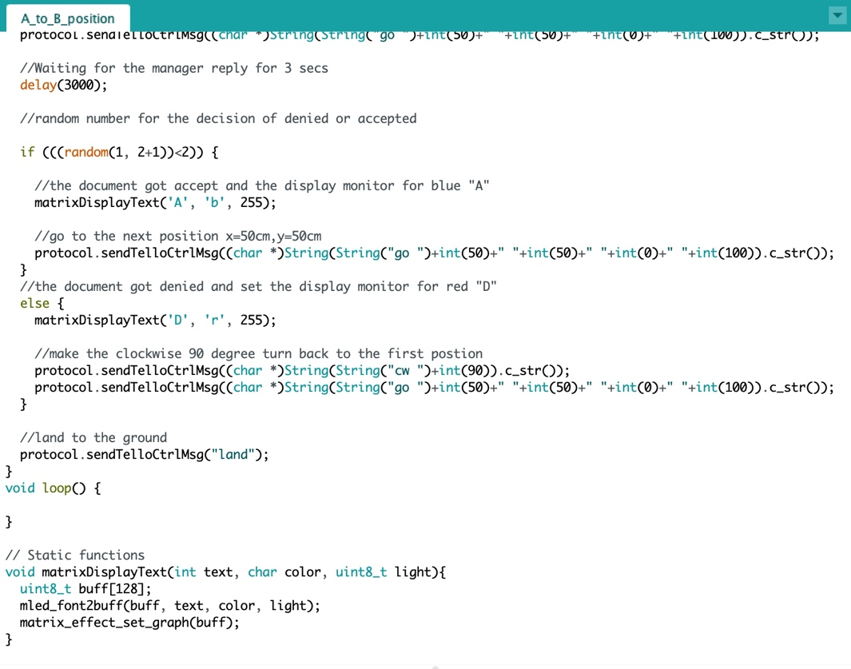

Finished date: 2/5

**Report 2 Outline:**

I have finished the drone decision path program (Drone_Flight_Function) and the data system program (Document_Process_Data). In this phase, I put two programs together and implement on the drone. The data system program got the data from the drone decision path program. However, it only worked well if the data runs below 2000 rows. I will change my data system program to make the two programs more integrated. Make It will not crash during operation. And also try generic proxy for Arduino, it helps to read a file and return data to Arduino.

From the last report, I used the randomly decision function to create the drone route. And had not put the departments data into the Arduino code. After report 1, I add more decision functions into Arduino code.

Arduino code for the drone position changing from A to B / B to C / B to A/ C to A

A- The requested department

B- Director Office

C- Financial Office (Final approval department)

* **Step 1 Set the Path**

**Date: 2/16**

First, I set 6 different departments for the first requested document.

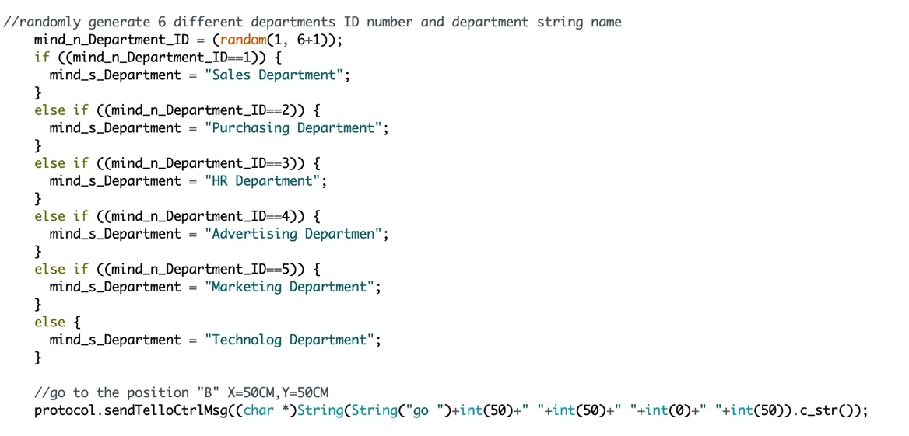

After the position A, the drone will go to position B (Director Office)

Randomly generate the number to decide the decision of the document approval. After the decision made by manager, the path will go next point or back to the original point.

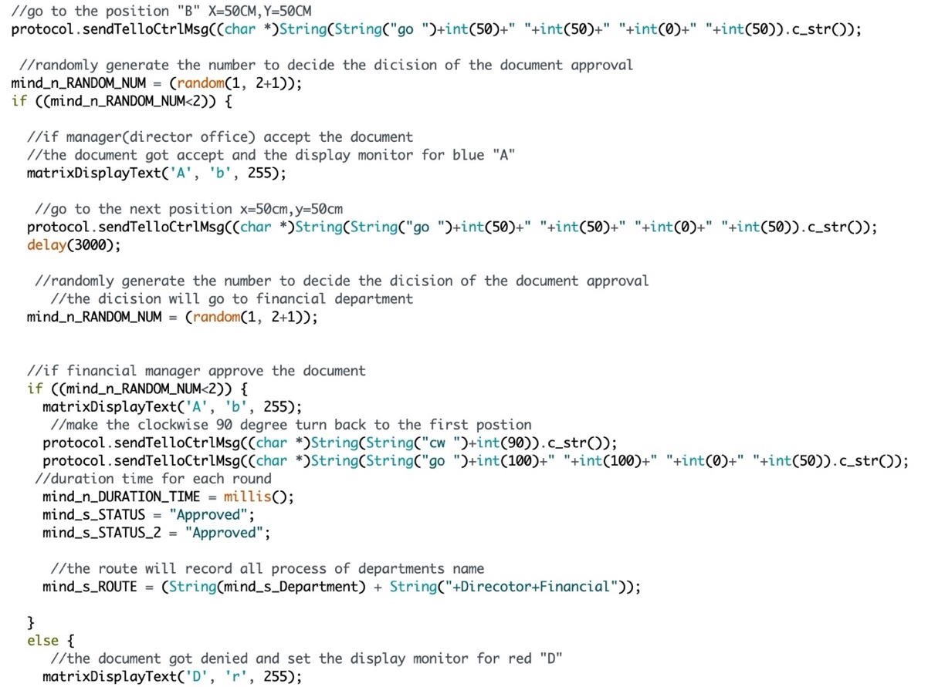

* **Step 2 Repeat the Flight**

**Date: 2/23**

At this phase, I chose to test the flight route 200 times. When the drone starts to flight, it

will go to the “for loop” function and the nest random number function. If the document has

not been approved, it will go back to last point and start over again.

If the document has been approved, it will go to next point. If the document runs all through

the point (document has been all approved), the drone will go back to point A and move to

next new round.

* **Arduino Code**

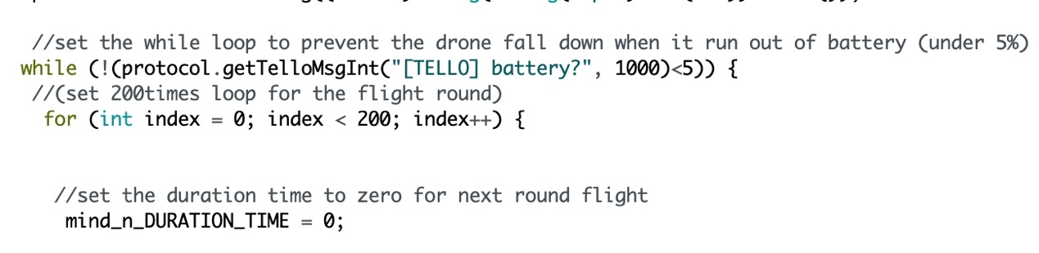

* **Step 3 Save the flight data to Excel**

**Date: 2/26**

Each turn of the flight, the flight data will save to excel at the end of the turn. And after the

data saved, the program will run to next turn and be saved to next row. The data will be

recorded as “Date”, “Department”, “Status_1”, “Status_2”,” DOC_ID” and “Route”. For

these data, I can get data which from a randomly decision and analysis which department

spend most of the time for the document approval or the volume of the documents in each

department. However, now I only can observe from the test data. If I can apply this in real

world, take the office for example, it might increase the efficiency of the work and reduce

the paper loads. Moreover, I can analysis every departments documents process which

make the office administration more clearly and smoothly. For now, because of Arduino

should be inserted into the COM 4 port for transfer the data to excel. So, if I start the drone

to fly, the data cannot be sent to the computer immediately. I wrote two files of Arduino

code which are Drone_flight_function (practical part) and Document_process_data (data

part).

* **Arduino Code**

**Set the variables of Data labels**

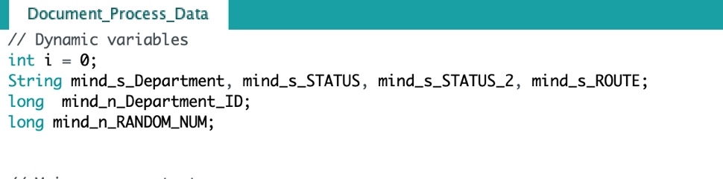

**The loop function for write the document process data row to row.**

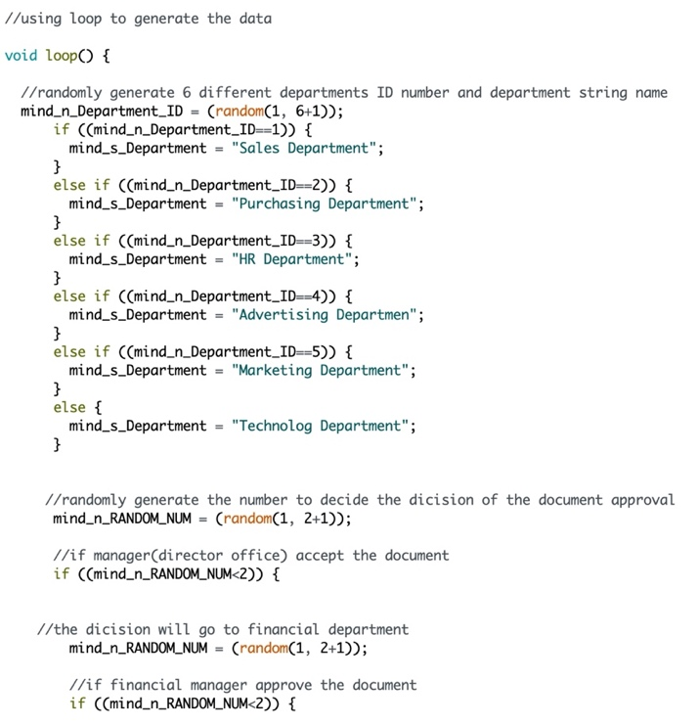

**“Serial.print()” object can call the data from Arduino to Excel**

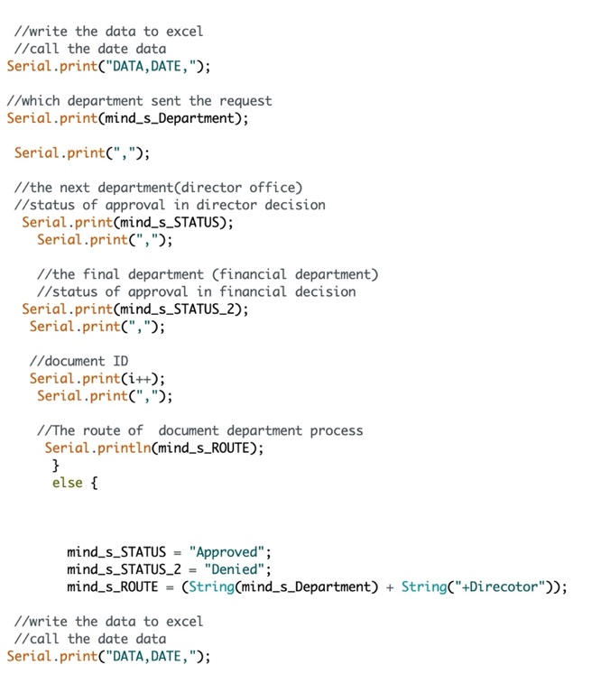

Should set the port to COM4 for connect to the Arduino open-source controller first

and upload the code to it.

 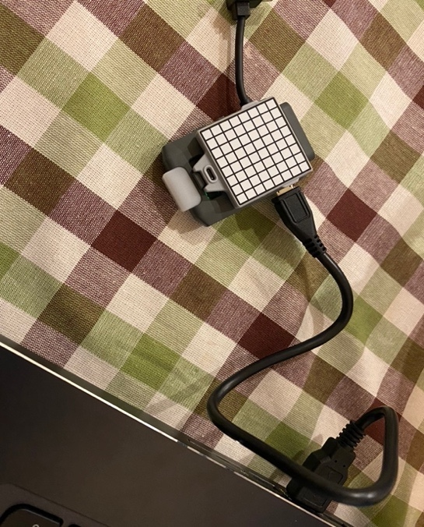

-Press the PLX-DAQ (Parallax Data Acquisition tool) button to connect the COM4 port

which had been upload the Arduino code to open-source controller.

-Start connected and run the loop function

-The data will generate randomly by rows

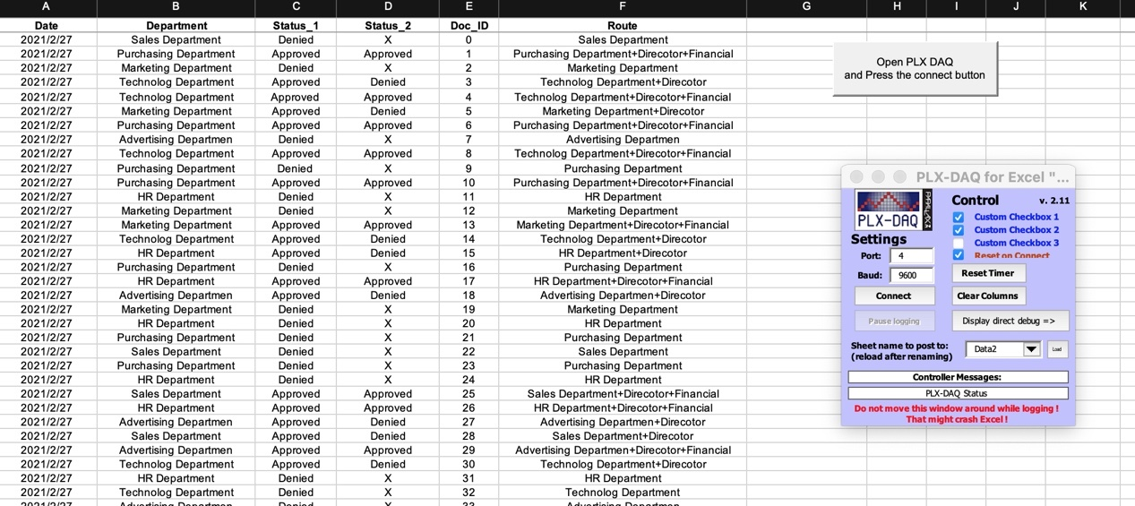

* **The Document Process Data (From Arduino to Excel)**

**Date: 2/26 & 3/13**

Date- The date same to same loop (will be updated and improved on next phase)

Department- Document requested from name of department

Status_1- Director Office Approval or Denied

Status_2- Financial Office Manager Final Conform

Doc_ID- The number of documents by time

Route- The process of document

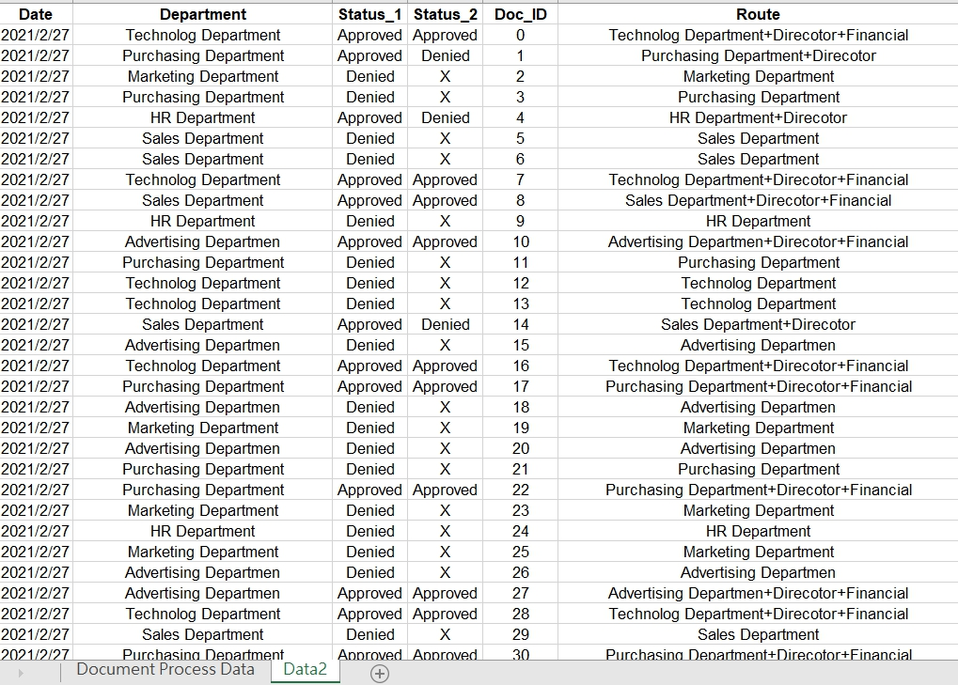

## Try using another tool to sending data (GoBetwino)

## Basically, the result is the same, but the hardware function is more smoothly (drone can go to the right place without system crashing)

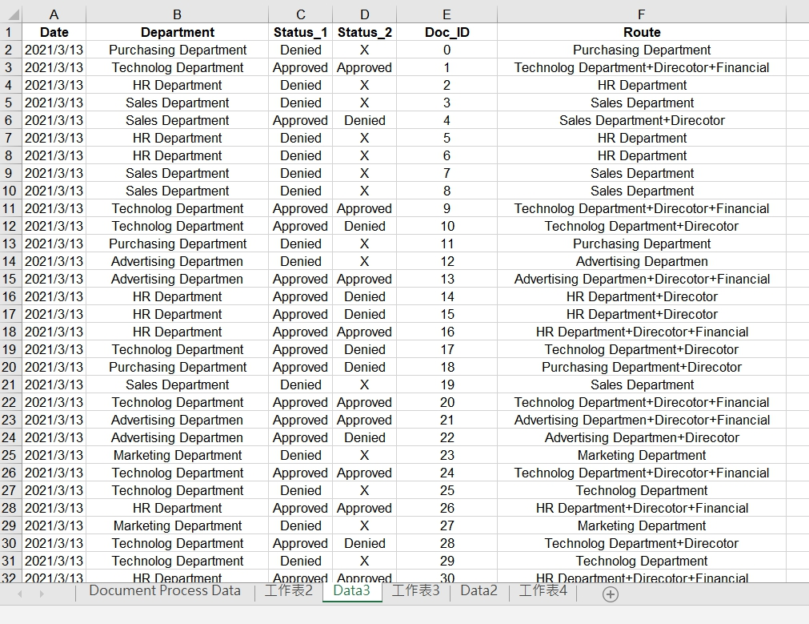

* **Step 4 Analysis and Some Ggraphs**

**Date: 3/10**

**The Director Office Approval Data in each department**

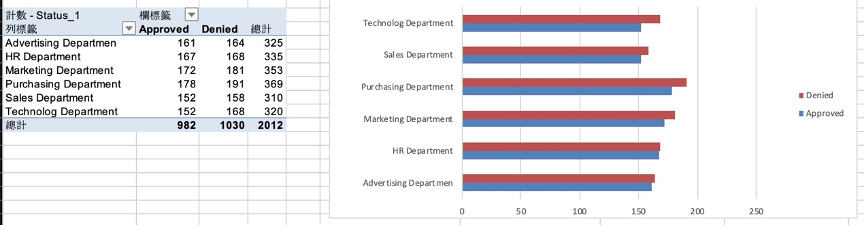

**The final approval – Financial Department**

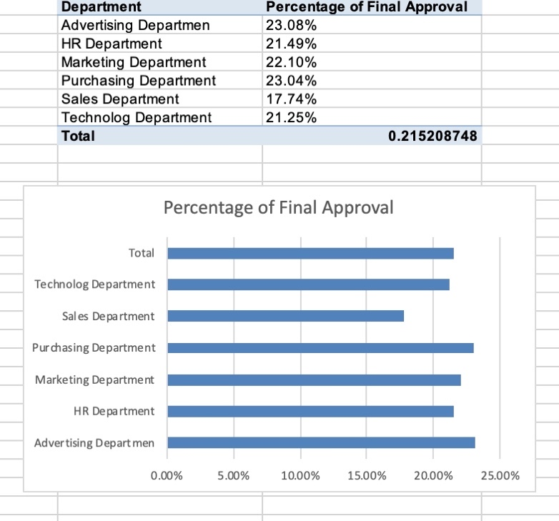

**Report 3 Outline:**

I have modified the data sending code and add other Arduino file to receive the data from drone memory. And for the drone implementation, the number of data write and read into chip (ESP32) is running good on the computer (COM 4 port). However, there is a problem during the flight. The battery only can at last 8-13 mins, therefore, the data cannot get much during the flight. So, I have written two different Arduino codes. One is for drone implementation (stored only 10 times flight data) and then link to COM port to retrieve data. The other one is running through the computer and then sending to the excel.

Adding EEPROM library to save(write) data during the flight

The microcontroller on the Arduino boards has 255 bytes of [EEPROM:](http://en.wikipedia.org/wiki/EEPROM) memory whose values are kept when the board is turned off (like a tiny hard drive).

EEPROM -setting the location size to 4096

These values will stay in the EEPROM when the board is turned off and may be retrieved later by another sketch.

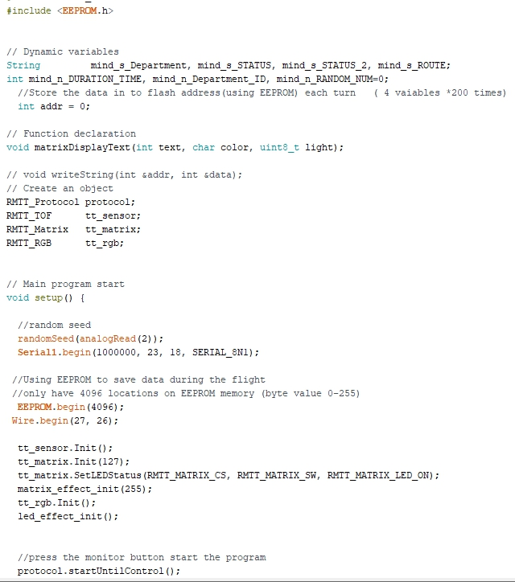

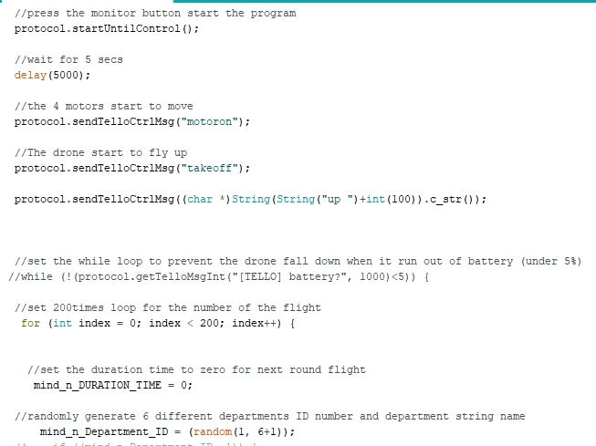

Write the data to each location

EEPROM.write only save byte (0~255)

So, for here, I set the number to each decision variables. ex: Department_ID, number 1 for Approval and 2 for denied

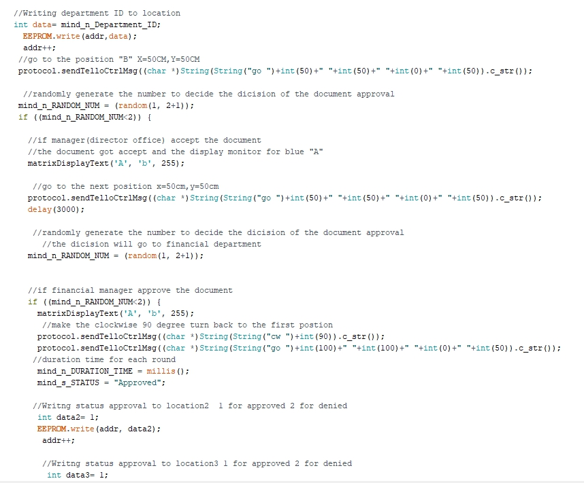

Route: number 1 for 1 point, 2 for 2 points and 3 for all points

(department-manager-financial office)

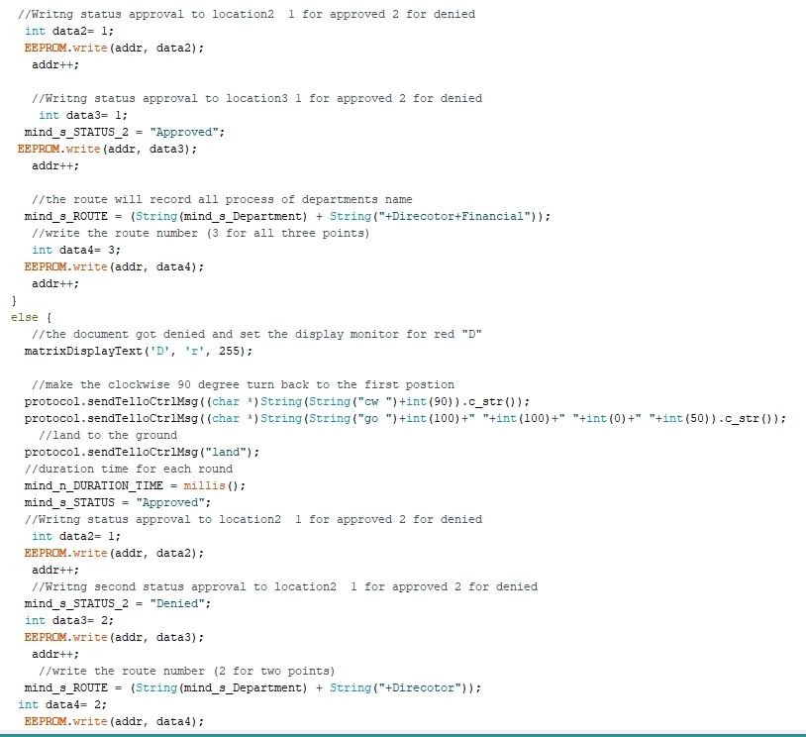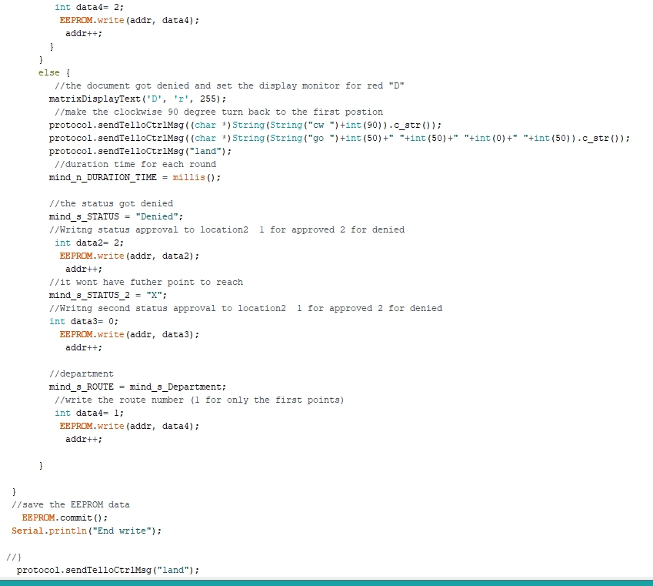

**Create the other Arduino code to receive and read the data from the chip**

Read the data from the memory of EEPROM

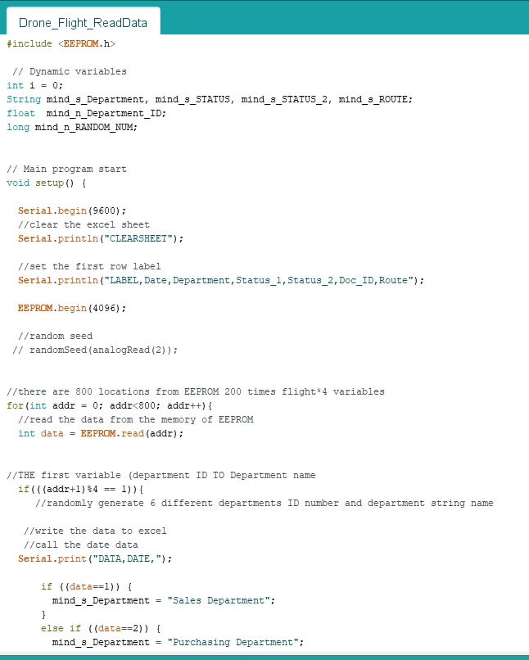

**Assign the byte data from chip to string**

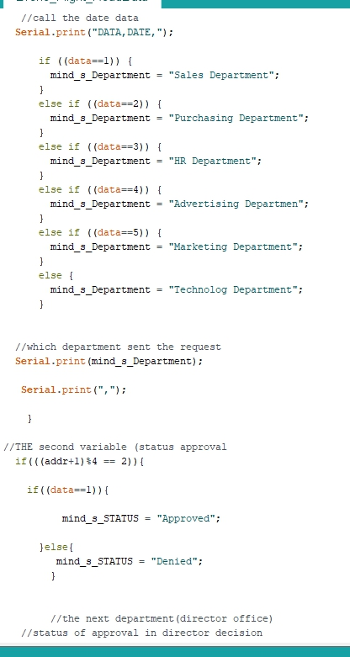

**There are 4 variables from the chip**

Department_id, status1, status2 and the route

Separate different variables from byte address to string

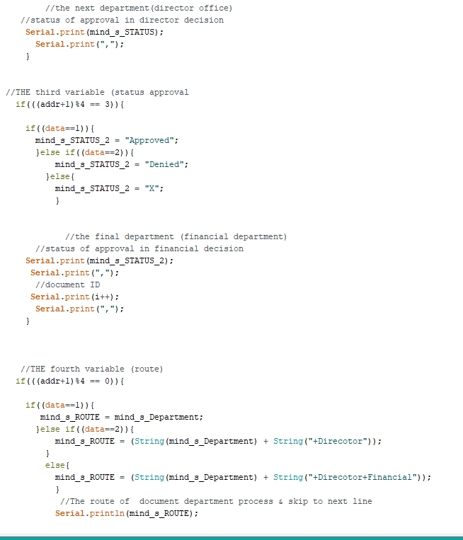

**Upload it to the COM4 serial monitor**

There are still some issues form the EEPROM memory and cannot retrieve the right data(byte).

Because EEPROM memory value should be set to 0 every time, otherwise the data cannot be rewrite. I am not fix this yet.

However, I will use SPIFFS (store into text FILE) if this problem still not been fixed.

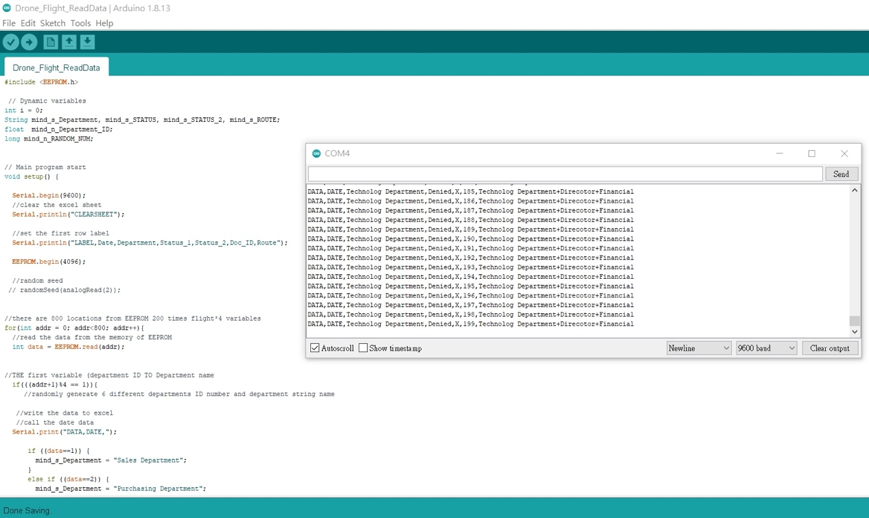

**Sending Data to Excel**

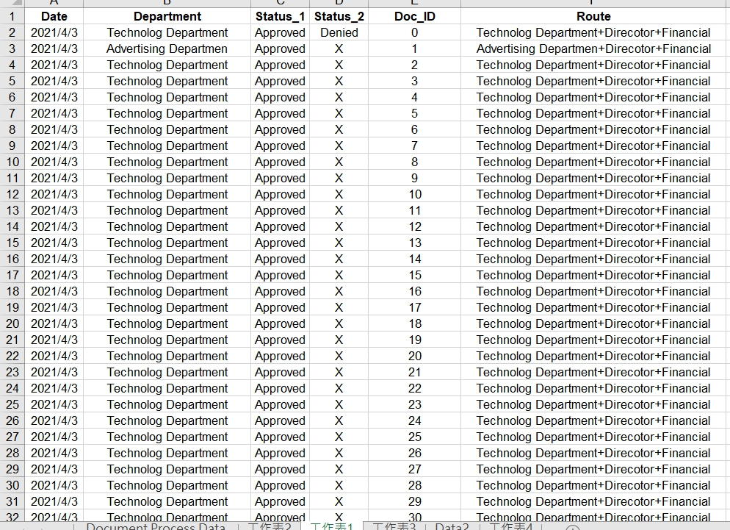

**Proposed Revisions**

**Report 1:**

Most of the progress are the same, only the device I have change to the education drone which can write Arduino and python for machine learning and AI.

**Report 2:**

None.

**Report 3:**

If the EEPROM memory cannot store the data perfectly and the other filing system (ESP8266 SPIFFS) still not work, I will add the Bluetooth/WIFI through ThingSpeak as the cloud database and receive the Arduino value. And the other thing is I need to use different Arduino code (less data during the flight) implement on drone since I cannot overcome the battery problem.